|  |  |
| --- | --- |
|  |  |
| **Computer Science Course Work** |  |
|  |  |
|  | 2022Dino Game |
|  | Leo GratwickSurbiton High School |

# **Contents:**

#### Analysis………………….…………………………………………………………………………………………..…………………..3

#### Objectives……………………………………………………………………………………………………………………5

#### Documented design…………………………………………………………………………………………………………….….7

#### Algorithms………………………………………………………………………………………………………….……….8

#### OOP Class Diagrams……….……….………………………………………………………………………………..13

#### Screen Design………….………………………………………………………………………………………………..17

#### Hierarchy chart…………………………………………………………………………………………………………20

#### Level Creation…………………………………………………………………………………………………………..21

#### Technical Solution……………………………………..………………………………………………………….………….….22

#### Background and Screen and level…………………….…………………………………………………….…22

#### Dino class…………………………………………………………………………………………………………….……36

#### Other OOP Classes (crystal, chest, heart, health bar, button, screen fade) ………………43

#### Timer…………………………………………………………………………………………………………………………49

#### Main game loop……………………………………………….…………………………………………………….…51

#### References…….……………………………………………………………………………………………………….…56

#### Testing…………………………………………………………………………………………………………………………….……47

#### Evaluation……………………………………………………………………………………………………………………….……62

# **Analysis**

I enjoy playing games and I am interested in the programming behind them, so I thought that I would use this opportunity to create my own game so that I could play it with my friends.

One of my favourite games is *Minecraft*, which is a sandbox game based off everything being made of blocks. You can play single-player or multi-player with your friends in which you can either play in survival (where you must collect resources and fight monsters to survive) or creative, where you can’t die, and you have access to every single block in the game and is commonly used for building things. There are also servers you can join which have mini games, adventure maps and many other interesting activities in *Minecraft*. Games like this take years to develop and are still releasing updates to this day. So as interesting it would be to program an open-world sandbox game like *Minecraft*, it would be very unrealistic however I can still take inspiration from some of the other features of *Minecraft* that I think make it a fun game to play.

In un-modded *Minecraft*, you spawn in a new randomly generated world and you need to break some of the blocks from a tree, turn them into planks and then create a crafting table. From this stage, you can use these items to make tools such as pickaxes, axes, and many other things when you have the correct resources to craft them. I really like the idea of being able to craft items with things that you as the player have collected and the ability make upgraded versions of the same item as you progress in the game and get better materials. I will try and incorporate crafting or upgrading items into my game, although it won’t nearly be a intricate as *Minecraft* crafting. In my game, the mechanics will most likely be something similar to combining an item with a weapon to make it stronger. Another part of *Minecraft*’s game design that I like is the feature of the health bar and the inventory at the bottom of the screen, so I might use something similar in the graphics in my game. Another thing I think is an interesting feature of *Minecraft* is that you can find chests in automatically generated structures, with useful items in them. I want to incorporate a feature similar to this into my game, where if you go into the right room you are able to find chests with useful items that you can use to upgrade weapons or armour using a ‘crafting table’.

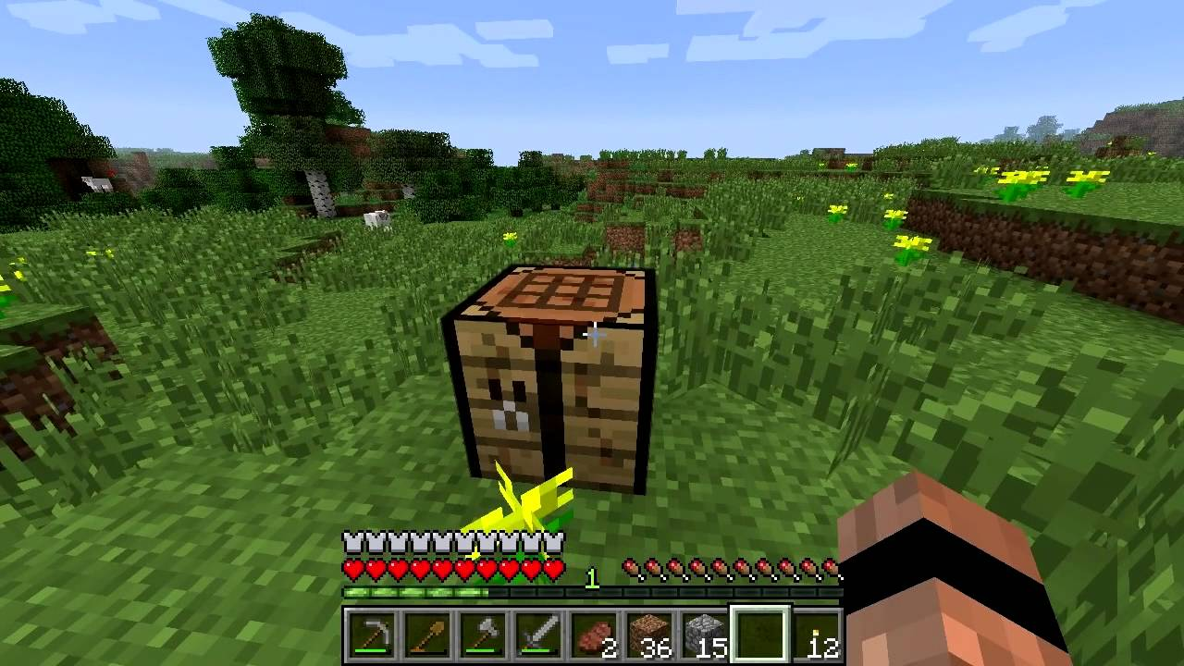

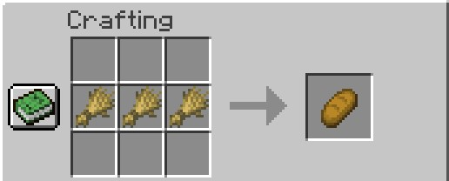

Initially, I wanted to do a game similar to *Dino Game* that you can play when there is no internet connection, or *Flappy Bird*, where you go through randomly generated terrain and try and survive for as long as you can, as those are easy to understand games. However, in my opinion, this is a very simple concept and after a while it gets repetitive and boring. So I moved on to researching and thinking about something slightly more complex, such as *Fire Boy and Water Girl* and the original *Mario* games. I played *Fire Boy and Water Girl* with my friends a lot when I was younger, and I really like the design of the maps as they are specifically made so that you need to figure out what you need to complete the game and teamwork is crucial to completing the level. I also admire that there are many different levels, in which you can get different scores depending on how many crystals you pick up and how fast you complete the level. Another feature that I think makes it interesting is that you can see the whole map so you can think ahead and try to figure out what is needed to advance. In *Mario*, I like how you can use tunnels to get to different places and secret rooms with the enemies that you can beat, I also like how there are enemies on the way to the end of the level that can attack you and make the level harder to beat. Another thing I admire in *Mario* are the maps, they are different to the maps in *Fire Boy and Water Girl*, as to complete levels you need to go to the very end of the level and touch to flagpole. Another feature that is different is that, compared to *Fire Boy and Water Girl,* you can’t see the whole level and as the player progresses, the level is unveiled. I will further take inspiration from some of the features of *Minecraft*, such as crafting and being able to upgrade items to be better and the more you progress in the game the more you can upgrade your items.

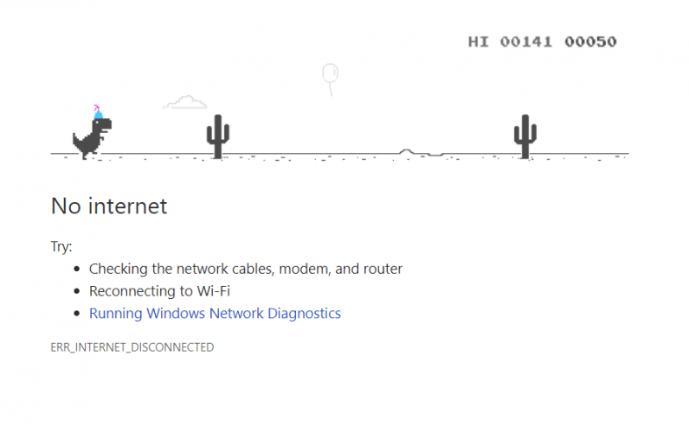

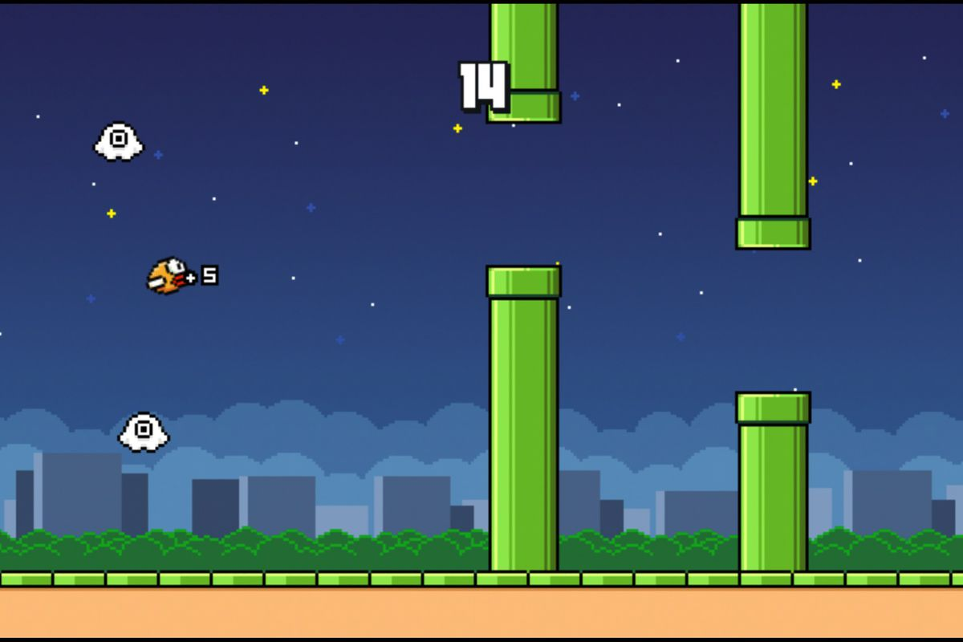

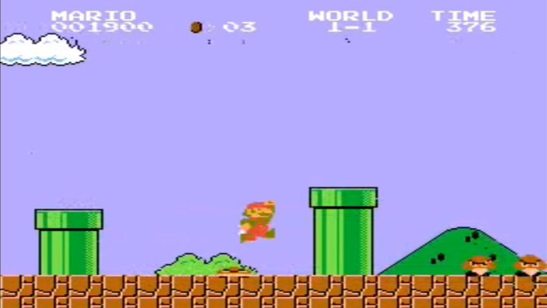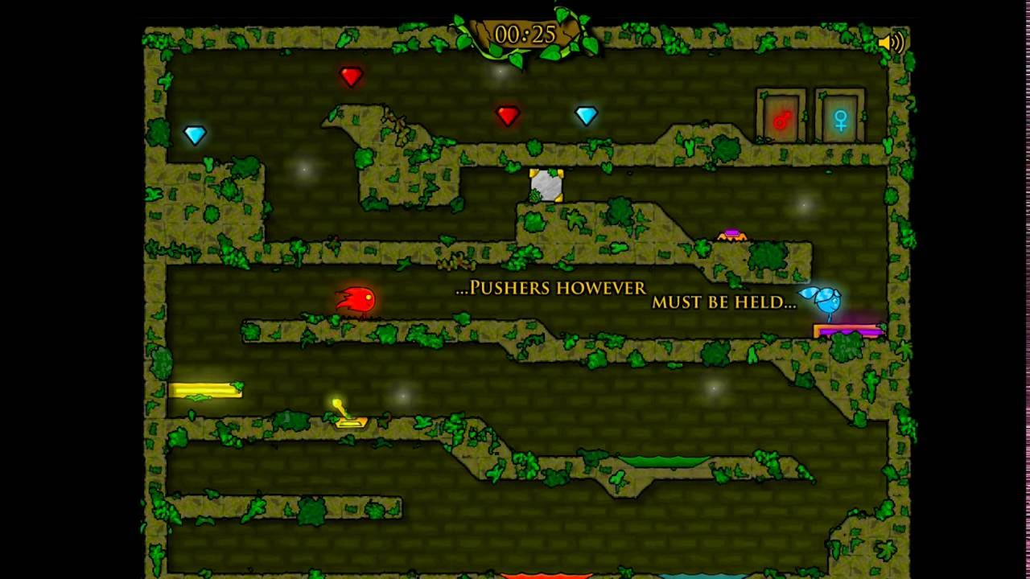

I decided that the target audience for my game would be people around my age, as I want to make a game that me and my friends would enjoy playing. I asked some of my friends about some of their likes and dislikes in regard to the games that I mention above, which I have achieved by sending them a survey to complete. The main answers I got were that they liked how the games were simple and easy to understand and yet still fun to play at the same time. From this feedback I will try to make the game simple to understand and ‘pick up’ as you play, meaning that I will try to make the game controls very simple, for example, ‘jump’ will be the space bar. I also received feedback about how they enjoyed the teamwork aspect of *Fire Boy and Water Girl* and *Minecraft*, they liked the way that they could control their character at the same time as their friend and they couldn’t get to the exit unless they worked together to flip levers and press buttons to open doors. Despite this, I don’t think I will be incorporating a feature like this, as I intend my game to be single player.

My game will be a platform game with around 5 levels, each level having 3-8 enemies of different levels which deal different amounts of damage to the player and have all different amounts of health. All enemies will drop items when they are killed, whose loot you can use to upgrade your attack or defence statistics which was inspired by the crafting in *Minecraft*. Each level will also have hidden chests that you can go to go, all of which are slightly off route meaning that the loot gathered can be used to upgraded attack or defence levels before reaching the end of the level. At the end of each level there will be an exit sign which the player has to pass to reach the next level, similar to the flagpole in *Mario*. All the players items and the players health will be always displayed on the screen.

**Objectives:**

Player

The player can go forwards backwards and jump using A, D, Space and sprint with S

Player can deal damage to enemies using right click, however there should be a cooldown after using an attack

There should be walking, jumping, and attacking animations for the player’s movement

If the player is killed, they should respawn at the start of the level

The player has a set amount of health depending on what armour they have

At the start of each level the player should spawn with the lowest grade attack and defence

The players health, attack and defence levels and number of gems should be displayed on the screen

Enemies

All enemies should be able to fight and deal damage to the player

All enemies should have a set amount of health and be able to be killed by the player

All enemies should drop item(s) after being killed

Enemies should not respawn after being defeated, unless the player dies

Crafting

The player should be able to craft, to upgrade attack and defence by using 1 2 3 4 5 6, by using drops from defeating enemies or items found in chests

The player should only be able to increase a stat if they have the correct crystal to do so

Attack and Defence

Attack and defence have levels 1-10

The level of the attack determines how much damage it does to enemies and the level of defence determines how much damage the payer will take when hit by an enemy þ

Chests and Drops

Chests will spawn in set locations of the map in each level

Each chest will contain 1-2 random crystals or hearts

Each enemy will drop a set item, the type depending on the health of the enemy

There are 4 different items: green, red and blue magic crystals and hearts

Green magic crystals will increase the level of attack/defence by 1 level, red by 2 levels and blue by 3 levels

Hearts restore the players health

Levels

There should be 5+ levels

Each level should have a different map

Each level should be progressively harder to complete

The player should be able to complete the level by running to the end of the level where the exit sign is

Add in a timer for each level

Other

Export game as a .exe file so that it can work independently without python downloaded

# **Documented design**

For my technical solution I installed a set of Python modules, called Pygame[1], which are designed for creating 2D video games in Python. These include things like computer graphics, so I can load in images and use them as sprites and also, I am able to render images and shapes in a window, and sound libraries, so I can add sound effects to the game, that are crucial to creating a video game.

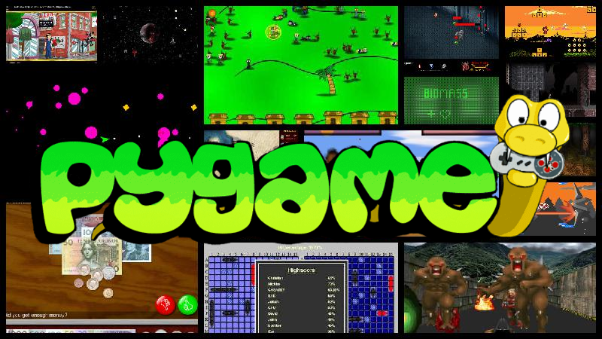

Algorithms

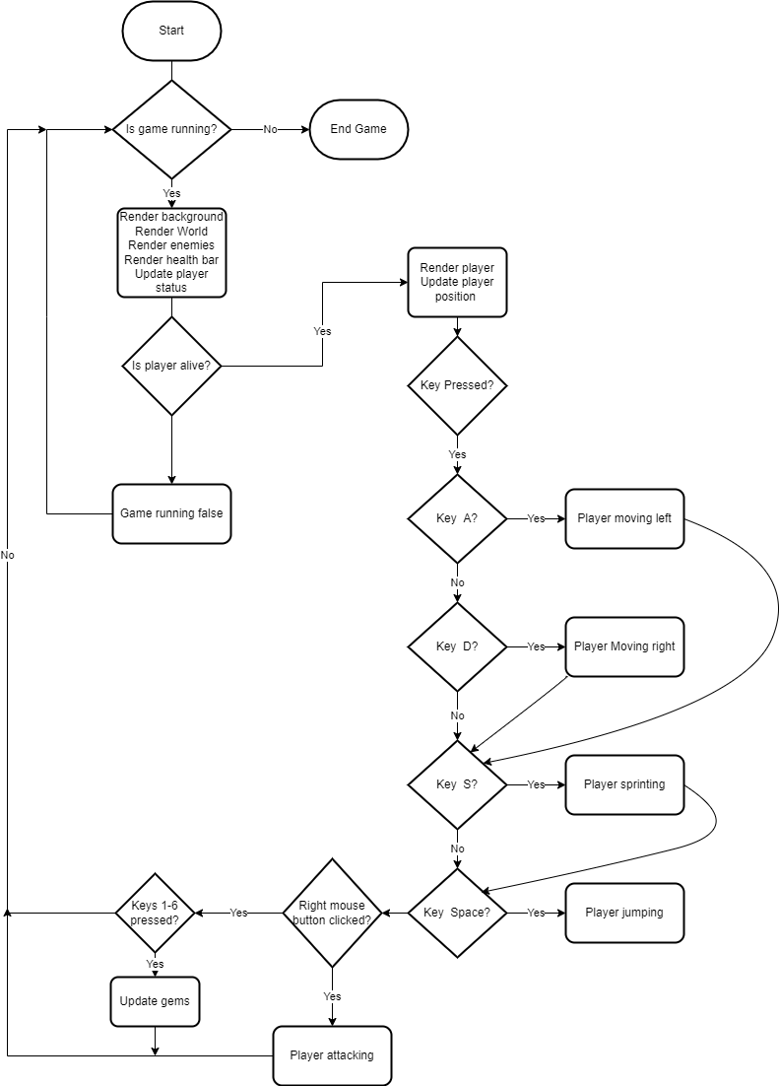For my project to work I will need to use a wide variety of algorithms, from a main game loop to player movement algorithms

This is a flowchart I made for the main loop of the game that runs while the game is open, it renders the background and the level, then it checks if the player is alive and based on the keys pressed it updates the player class, it also renders and updates the enemies, the gems and everything else in the game.

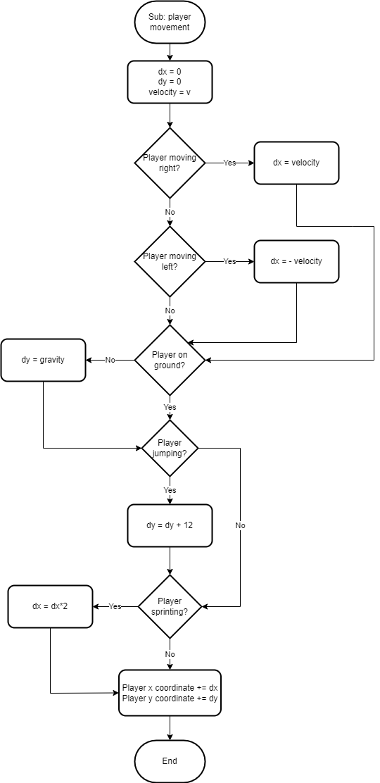This flowchart shows a basic algorithm for player movement, where player moving left, right, jumping and sprinting are variables passed in from the main game loop where the player presses keys to control the player. The layer velocity is set beforehand and is how far the player moves per frame, whether it is negative or no depends on the direction of movement of the player. If the player is on the ground the y coordinate won’t change so the player won’t fall through the ground, however if the player isn’t on the ground gravity need to be applied to the y coordinate, so the variable gravity should be a negative constant so that it acts downwards. When the player jumps the y coordinate is increased by a constant once in this case 12, but this could be changed depending on how high I want the player to jump. If the player is sprinting the change in the x coordinate doubles which doubles the speed of the player. Lasty the change in x (dx) and the change in y (dy) are added to the current x and y coordinates of the player, which is where the player will be rendered in the next game loop.

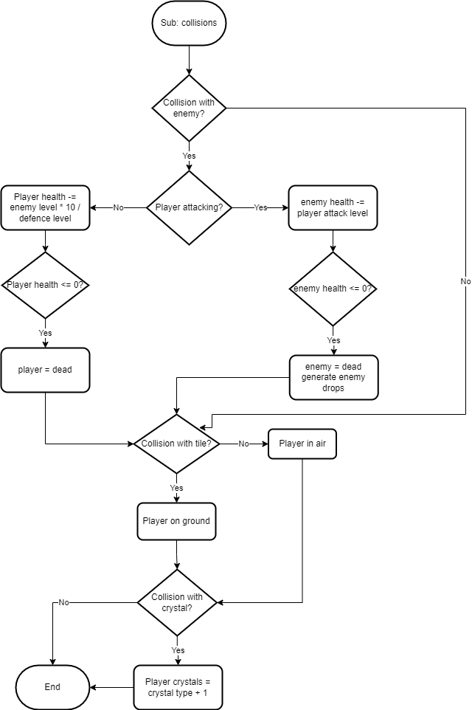This method of the player class will be for handling collisions, of everything in the game with the player. Collisions with enemies are checked, if the player is attacking it does damage to the enemy depending on the attack level, however if the player is not attacking the enemy does damage to the player depending on the level of the enemy and the defence of the player

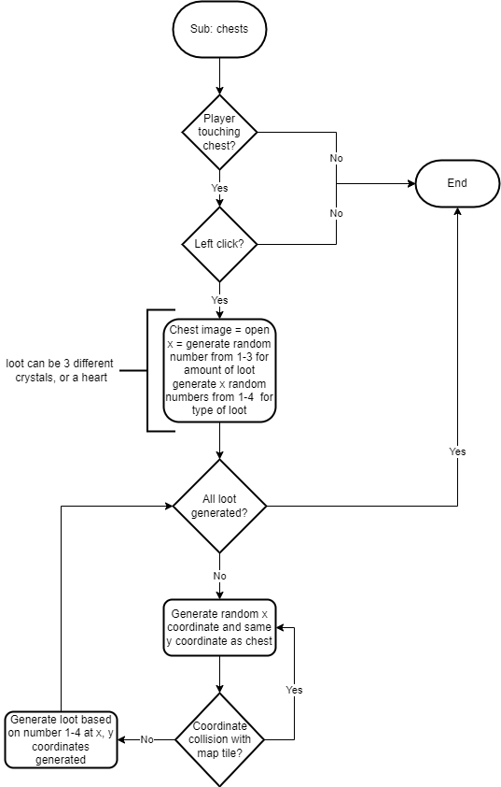This algorithm will be a method of the chest class, it checks that the player is touching the chest and then the player needs to left click it to open the chest, when the chest is open, it generates a random amount (1-3) of random loot items and then finds coordinates that aren’t inside the ground to place them at.

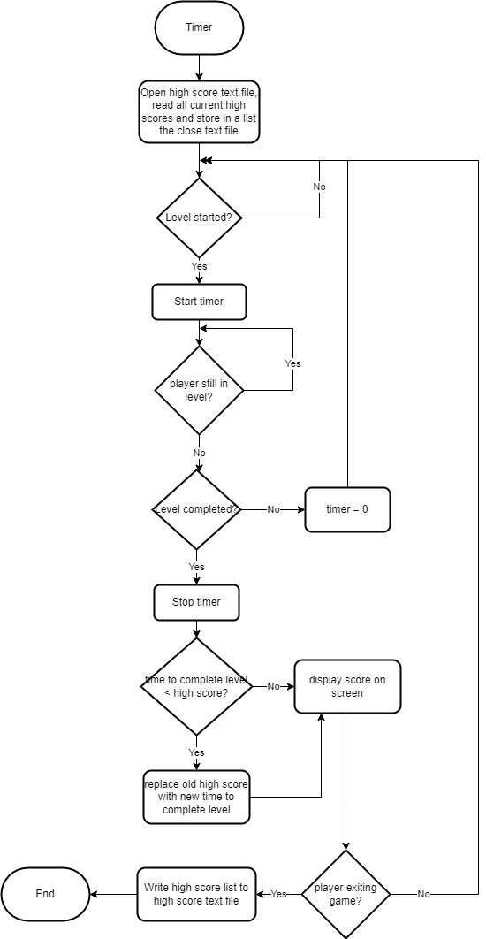This will be the algorithm for the timer in the game. I will have a text file containing all the current high scores, so that it can be used every time the game is opened and not only have the high scores for every time the game runs. At first the text file high scores will be extremely large so that the first time a player completes a level will almost guarantee to be a high score. First I will open the text file and read the contents into a list variable so that it can be used in the program. The I check if the level has started and if it had then the timer starts. If the player is not in the level anymore, they have either completed the level or died, so I will check if the level is completed. If this is false that means the player died, so the timer is set to 0 and it goes back to the start of the algorithm. If the player has completed the level, their time is compared to the current high score and if it is smaller then it replaces the current high score in the list. Then the time is displayed on the screen. When the player exits the game, the high score text file is opened and all the new high scores are written into it, so that they can be used the next timer the user plays the game.

OOP Class Diagrams

My game will be based around object-oriented programming and calling all the methods from the classes in the main loop to update and render the images of everything in the game including the player, the enemies, the chests, the level and all the other things that will be in the game. Most of the classes I will create will have images that will be saved in the same folder as the main programme, and also have coordinates to render them at. Classes such as chests and gems will be put into an array every time an instance of them is created which will make it easier to call the update and draw methods in the main loop as I can just use a loop an iterate and call the methods of all the objects. This will also make it easier to remove things such as crystals and hearts after they have been picked up and I will be able to just remove them from the list and they will no longer be rendered or updated.

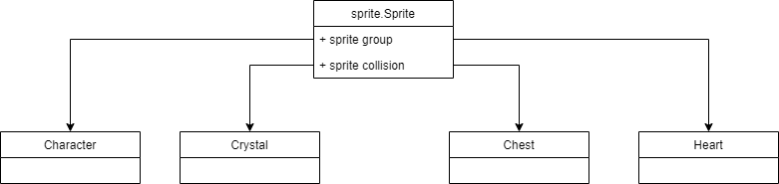The diagram below shows all the classes which will inherit a Pygame class called sprite.Sprite, which allows me to do things sup as use built in entity groups and functions, as well as other things including sprite collision detection.

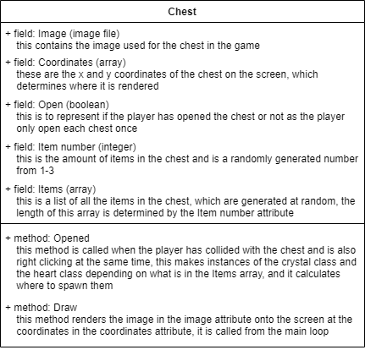

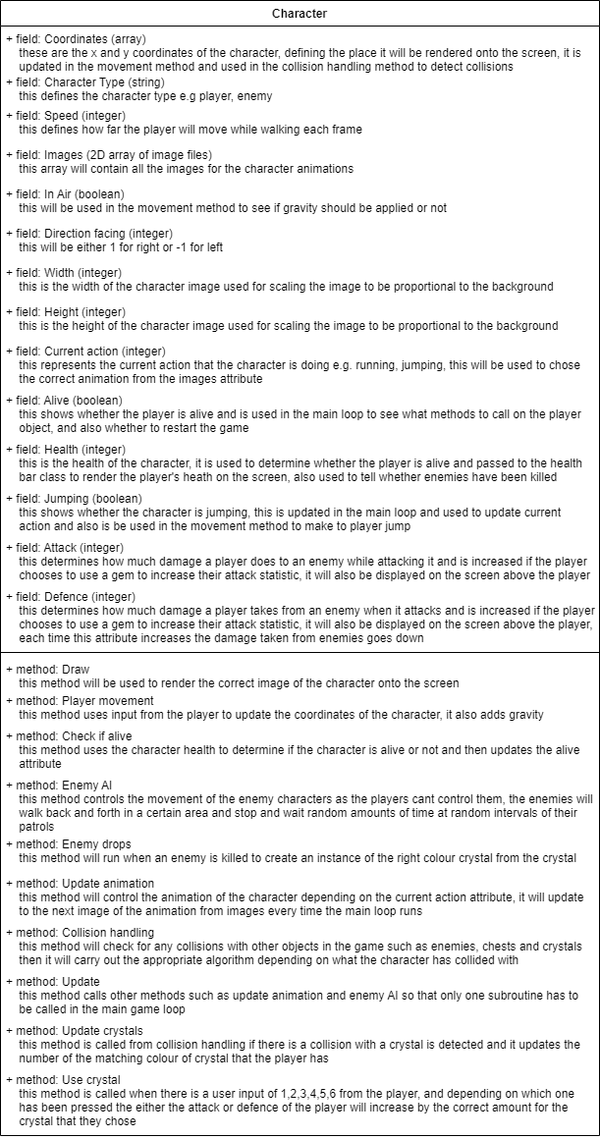

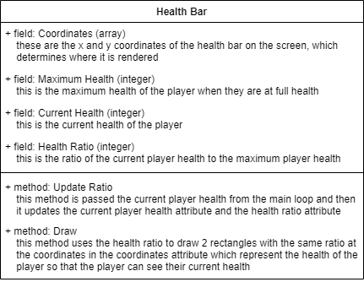

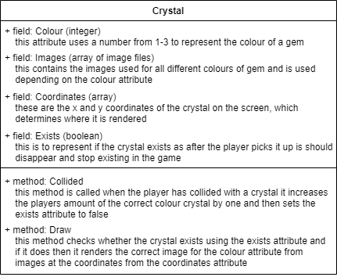

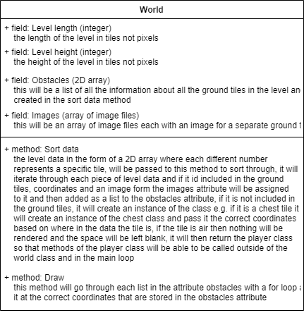

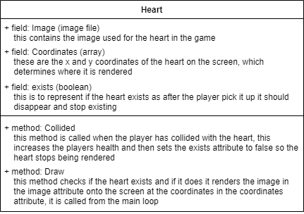

Screen designs

For my game I will need images for everything including the player, enemies, background etc. I went online to some free sprite websites[2], and pixel art websites to find some sprites for my game.

I used an online sprite cutting website[3] to split the long sprite sheets like the one below into separate images for the animations, also for some sprites I needed to remove the background[4].



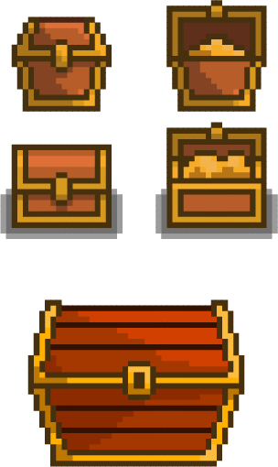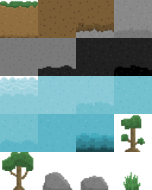

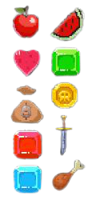

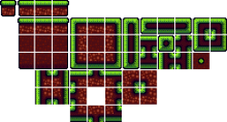



Above is an example of a sprite sheet compared to a single sprite that has been cut from the sprite sheet

I also used a website[5] that pixelated images for some of the more detailed sprites so they would have the same amount of detail as all the other sprites

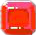

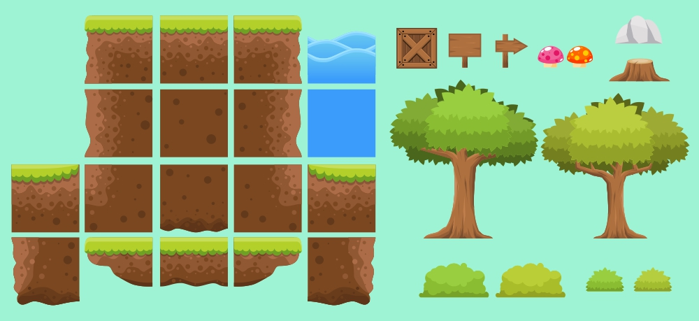

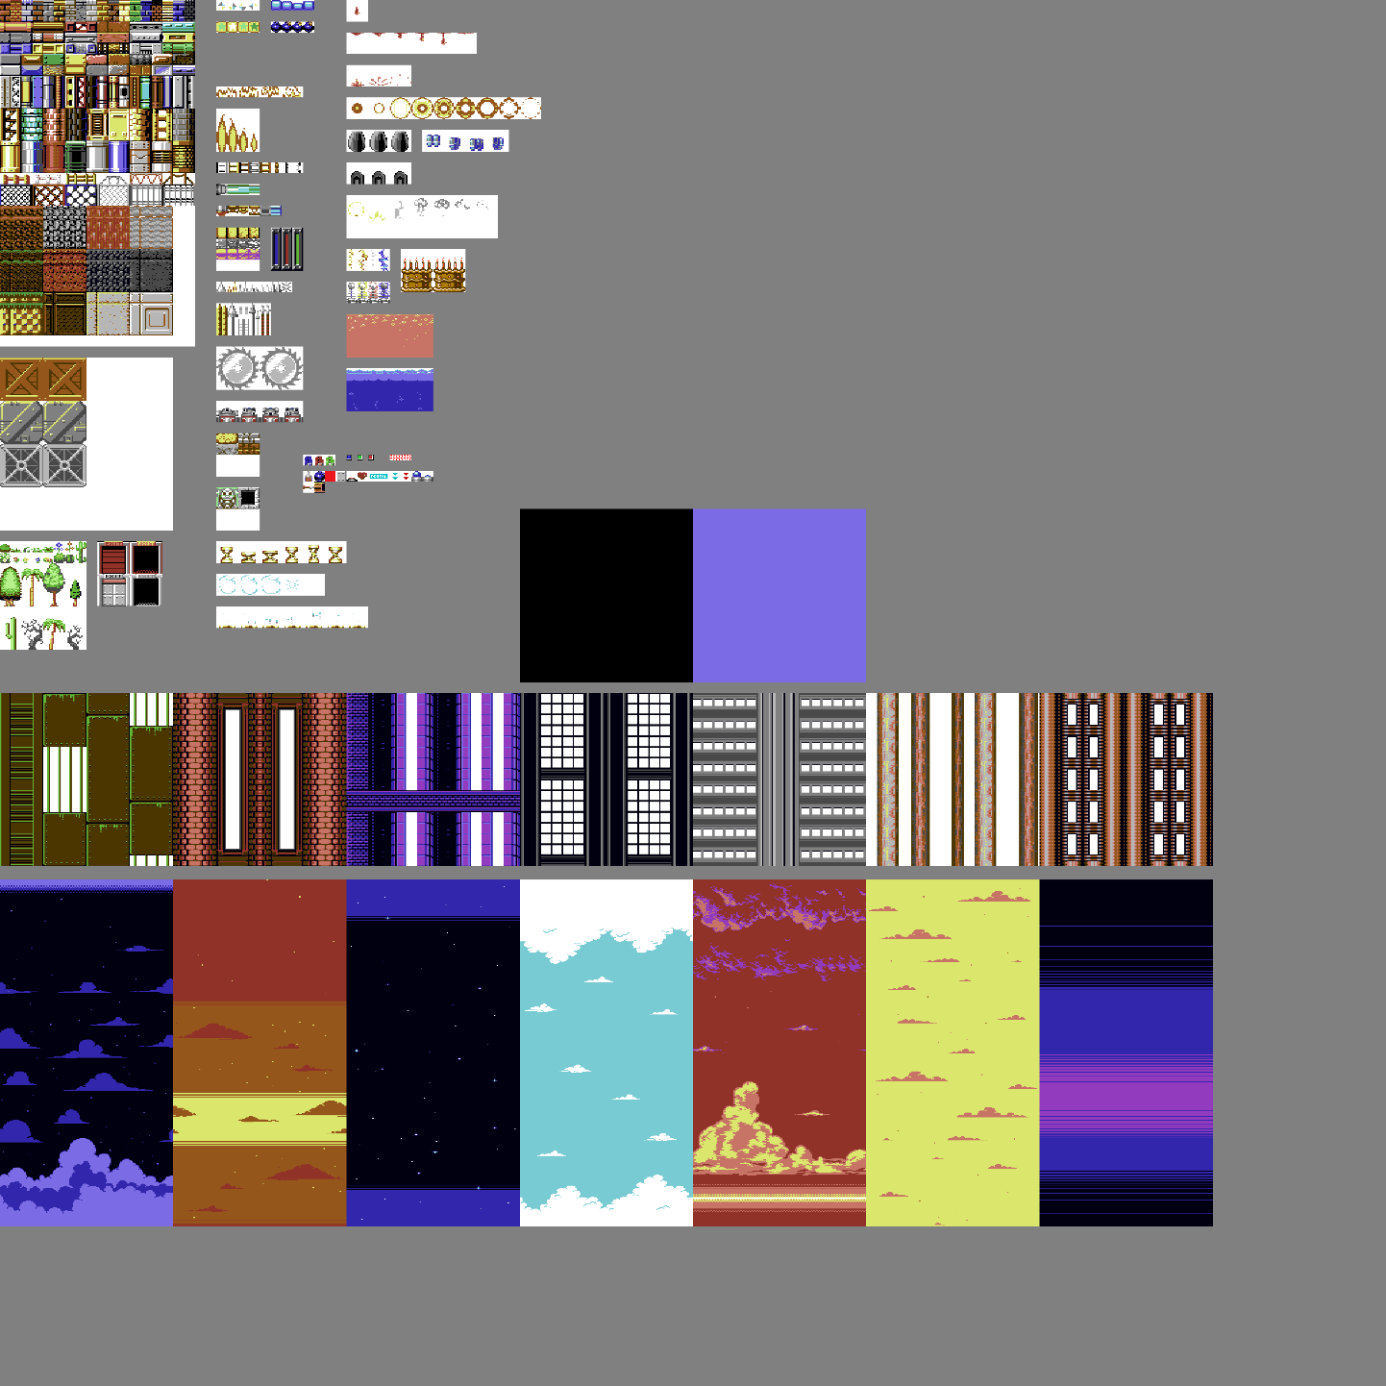

This image I found has may different types of sprites, however I like the backgrounds at the bottom of the sprite sheet so I will crop and use those as the background for my game

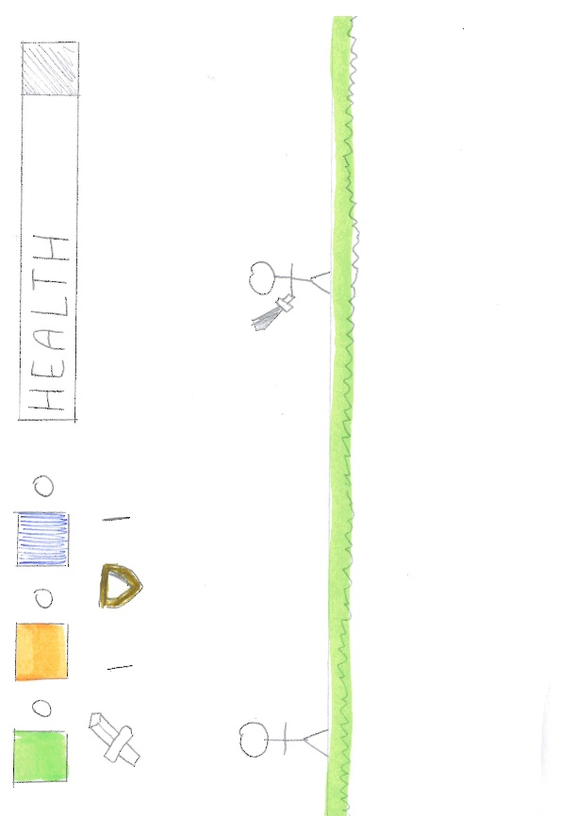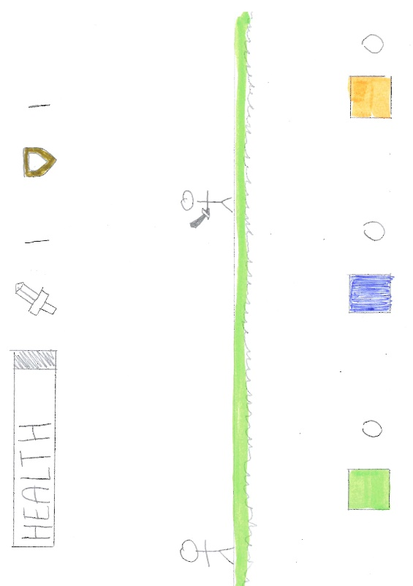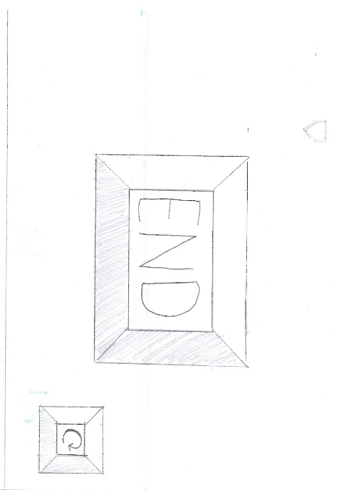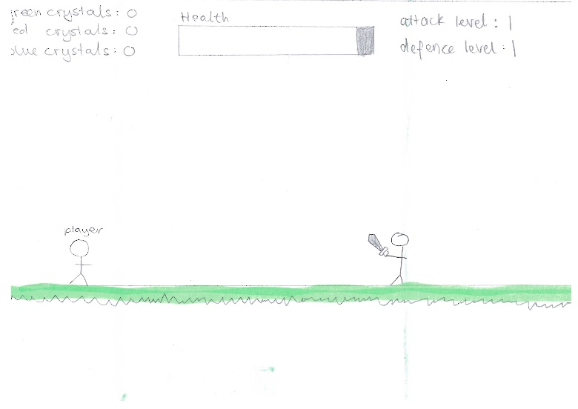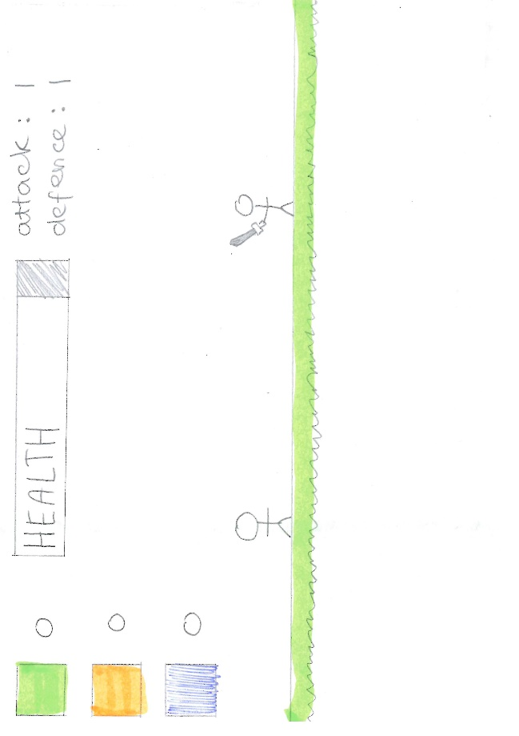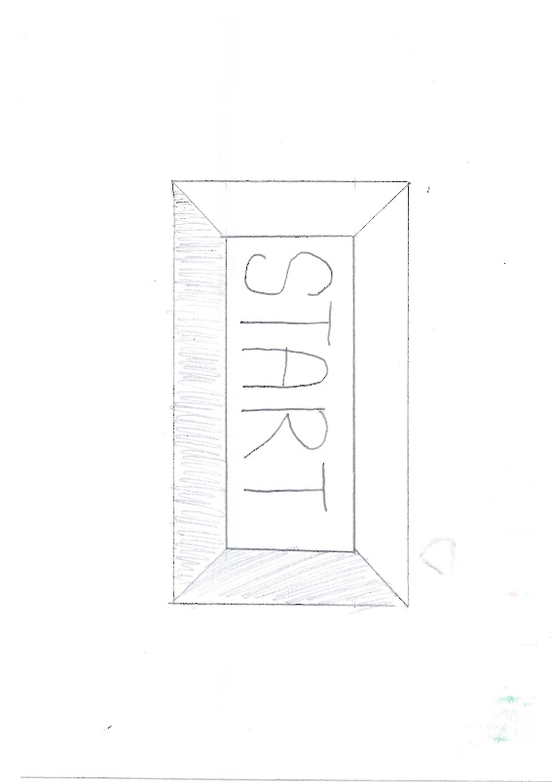After I was finished researching sprites, I thought about the screen design and drew a few designs of where everything on the screen would be including, the health bar, the number of each gem that the player currently has and the attack and defence levels of the player. I also screen designed the start, end and reset screens.

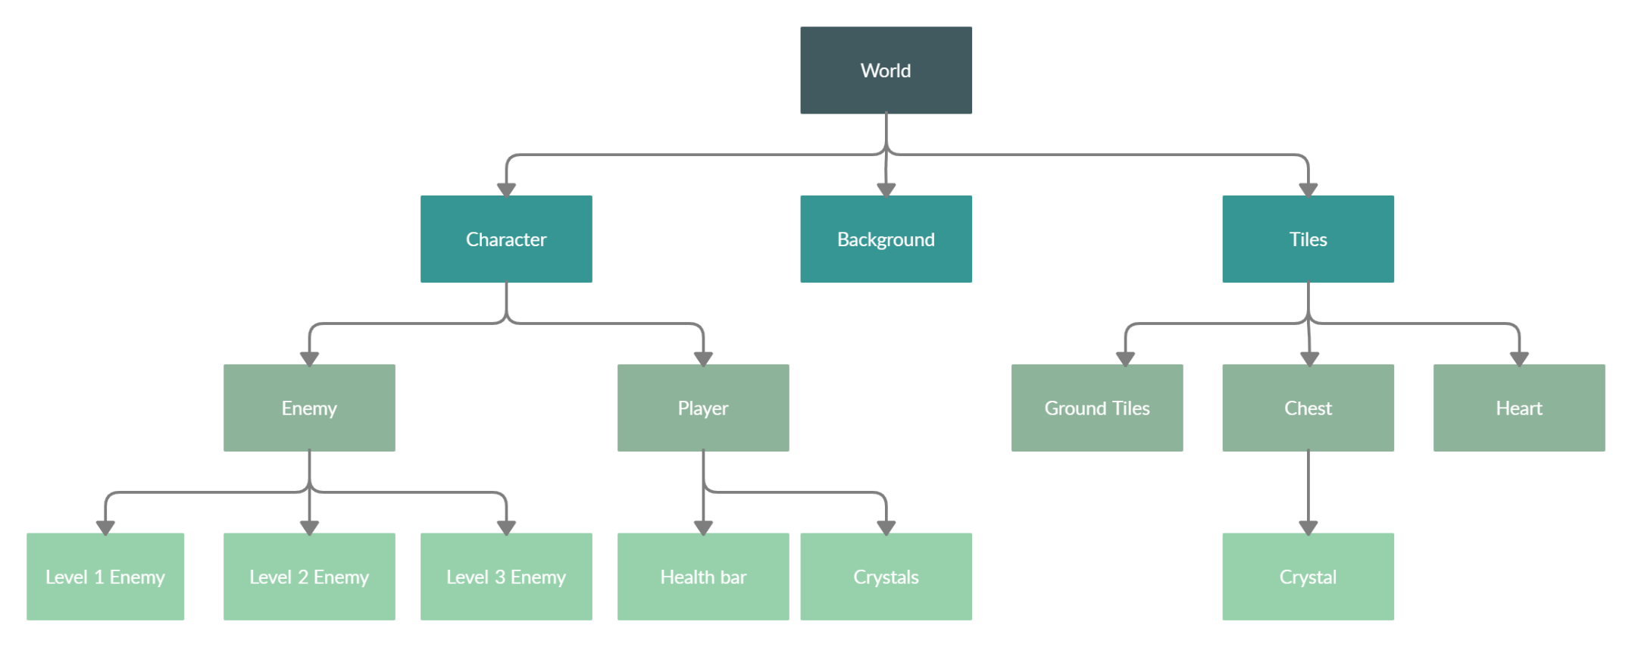Hierarchy chart

Level Creation

I also thought about how I would create each level of my game and I decided that the best idea was to have the game be based on tiles as then I could store levels much more easily as a 2-dimensional array, where each array inside the main array represents a row of tiles in the game. Each item in each row is a number which will represent what tile goes in that position, the numbers will include representations for the different aspects of the ground, chests, enemies, and players. In the class world, there will be a subroutine that processes all the data in this 2-dimensional array and creates an instance of each class in the correct location on the screen depending on where in the array it is. This subroutine will also make an array of all the ground tiles and handle the rendering of them in its draw function.

For example: Where, sky = 0, grass = 1, earth = 2 and player = 3

|  |  |  |  |  |  |  |  |  |  |
| --- | --- | --- | --- | --- | --- | --- | --- | --- | --- |
| 0 | 0 | 0 | 0 | 0 | 0 | 0 | 0 | 0 | 0 |
| 0 | 0 | 0 | 0 | 0 | 0 | 0 | 0 | 0 | 0 |
| 0 | 0 | 0 | 0 | 0 | 0 | 0 | 0 | 0 | 0 |
| 0 | 0 | 0 | 0 | 0 | 0 | 1 | 0 | 0 | 0 |
| 0 | 0 | 0 | 3 | 0 | 1 | 2 | 1 | 1 | 1 |
| 1 | 1 | 1 | 1 | 1 | 2 | 2 | 2 | 2 | 2 |
| 2 | 2 | 2 | 2 | 2 | 2 | 2 | 2 | 2 | 2 |
| 2 | 2 | 2 | 2 | 2 | 2 | 2 | 2 | 2 | 2 |

Level = [[0,0,0,0,0,0,0,0,0,0],

[0,0,0,0,0,0,0,0,0,0],

[0,0,0,0,0,0,1,0,0,0],

[0,0,0,3,0,1,2,1,1,1],

[1,1,1,1,1,2,2,2,2,2],

[2,2,2,2,2,2,2,2,2,2],

[2,2,2,2,2,2,2,2,2,2]]

I hope to have at least 4 levels by the time I finish programming the game, which become progressively harder the higher the number of the level, also the game should also automatically load the next level once the player completes the previous level.

# **Technical Solution**

I have attached my full solution as an appendix[6].

**Background and Screen and level:**

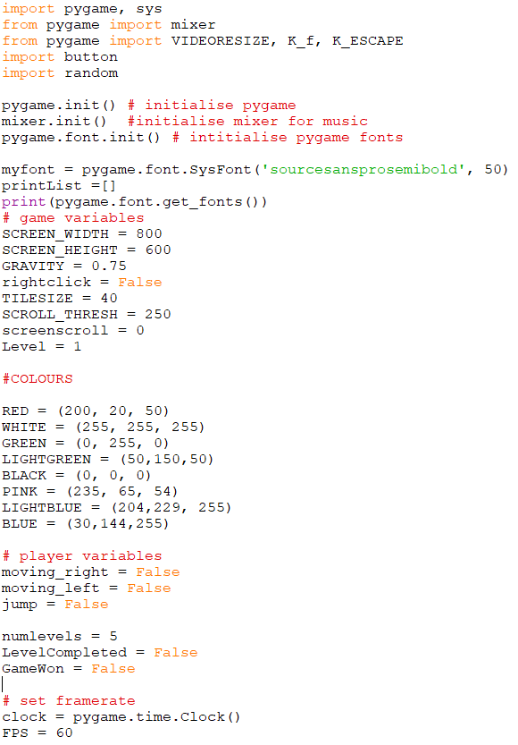Variables and Importing Pygame:

This is at the very start of the program, and it is the place where I import all the modules I am using, and I initialise most of the variables I will be using. At the start I import Pygame and sys. Then I import mixer from Pygame which is to control the music. I then also import random so that I can use a random number generator. I then initiate Pygame, mixer and Pygame fonts so that I can use text. Then I create my font and pass the arguments of the font and the size. Then I initialise the game variables such as the screen width and height, the gravity and the level. Then I initialise the colours as tuples passing in the red, green and blue values from 0-255. I then initialise the player variables and set the framerate.

I then create the Pygame surface called screen and pass the Pygame function the width and height initialised earlier. I then use another Pygame function – display.set_caption() to set the caption at the top of the window to say Dino Game.

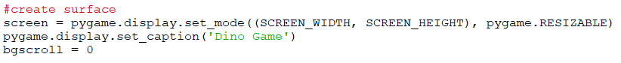

Loading images into an array:

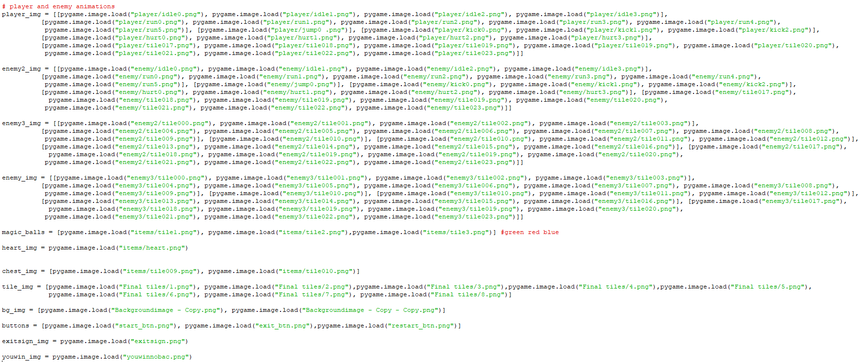

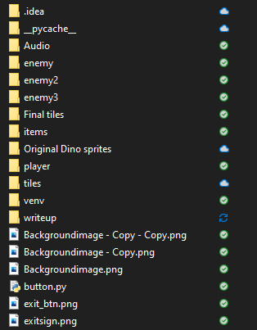

After initialising the variables, I load in all the images I will be using the Pygame function Pygame.image.load() and passing in the location of the file relative to where the program file is. For the players and enemies, I load in a 2D array of images where each list in the list is one specific action animation, so this can be used to load in the animations. The rest of the images are either loaded into 1D arrays or single variables. Some of the images are stored in folders and some are stored in the same folder as the program.

Music and sound effects:

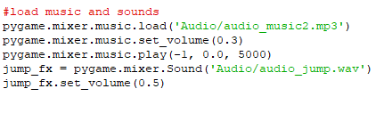I then load in the background music[7] using the Pygame function mixer.music.load() I then set the volume to 0.3 and play it using mixer.music.play() and pass in some variables, the -1 means that it will constantly repeat as long as the game is running, 0.0 means it will start at the very start of the game and 5000 means it will fade in for 5000 milliseconds.

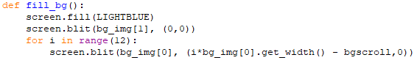Rendering background, writing on screen:

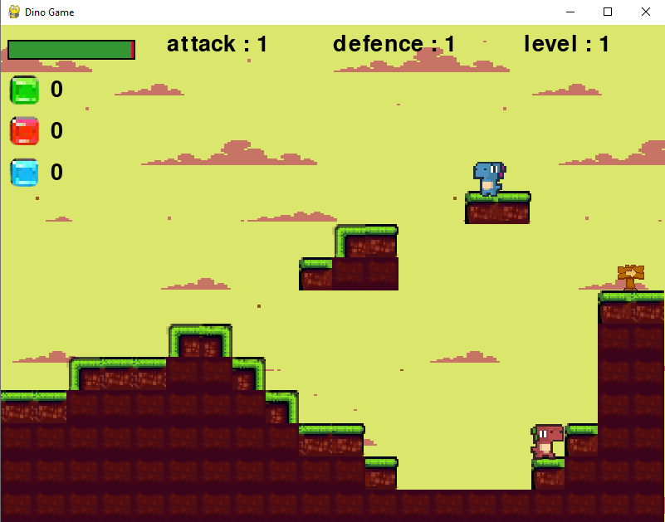This function fills in the background and the for loop renders the background image 12 times to make sure that it is enough to cover the length of the levels

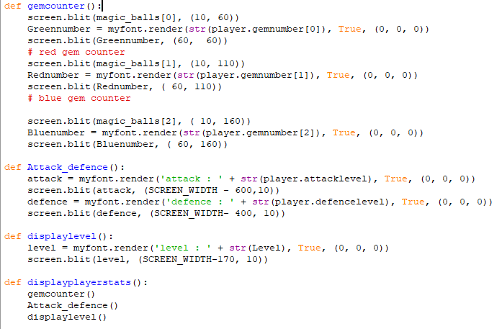

The first subroutine displays the number of crystals of each colour the player has by rendering the image used for the crystal and the rendering text using the Pygame function .render() and passing in the number of gems of that colour which is an attribute of the player object and the colour of the text in a tuple and then drawing it on the screen using the .blit() function. The second renders the attack level and defence level in the same way and the next one displays the player’s level. Then the last subroutine calls all the previous three so that I only have to call one function in the main game loop.

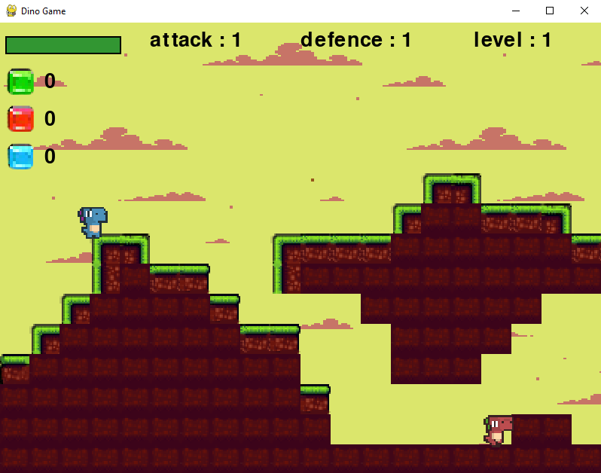

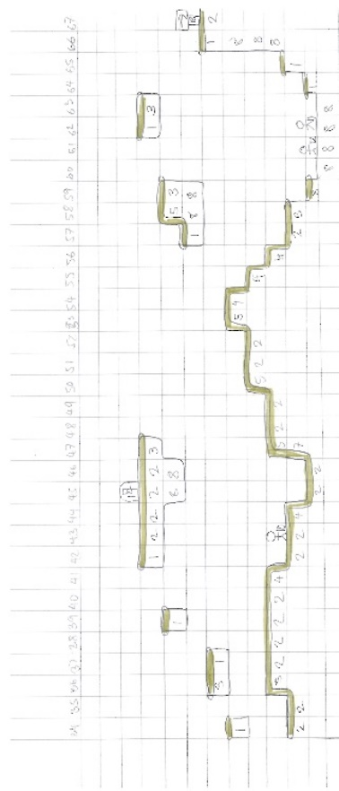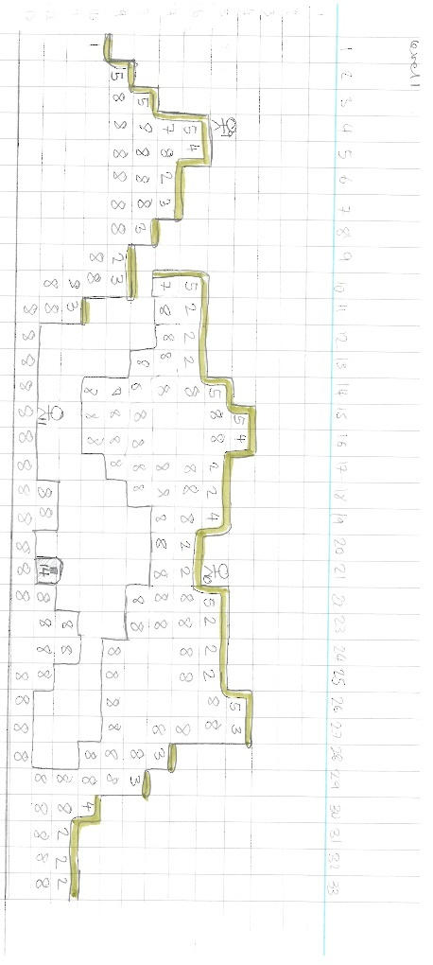Level storage, designs:

The levels are stored as 2D arrays however instead of making the design of the levels up as I went (which I tried and was very difficult as it was very hard to tell where everything was), I designed them on graph and square paper, so I had an idea of what they would look like when they were rendered. I tried to make each level progressively harder and, I took into account the maximum height the player could jump was two tiles and I also had to make sure there were no places where the player could get stuck.

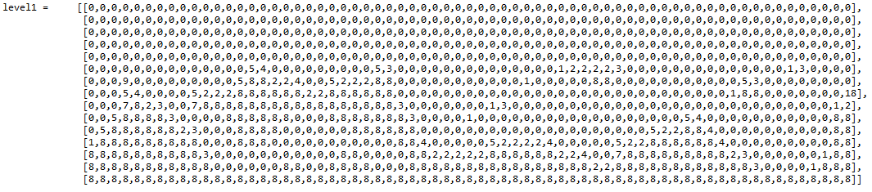

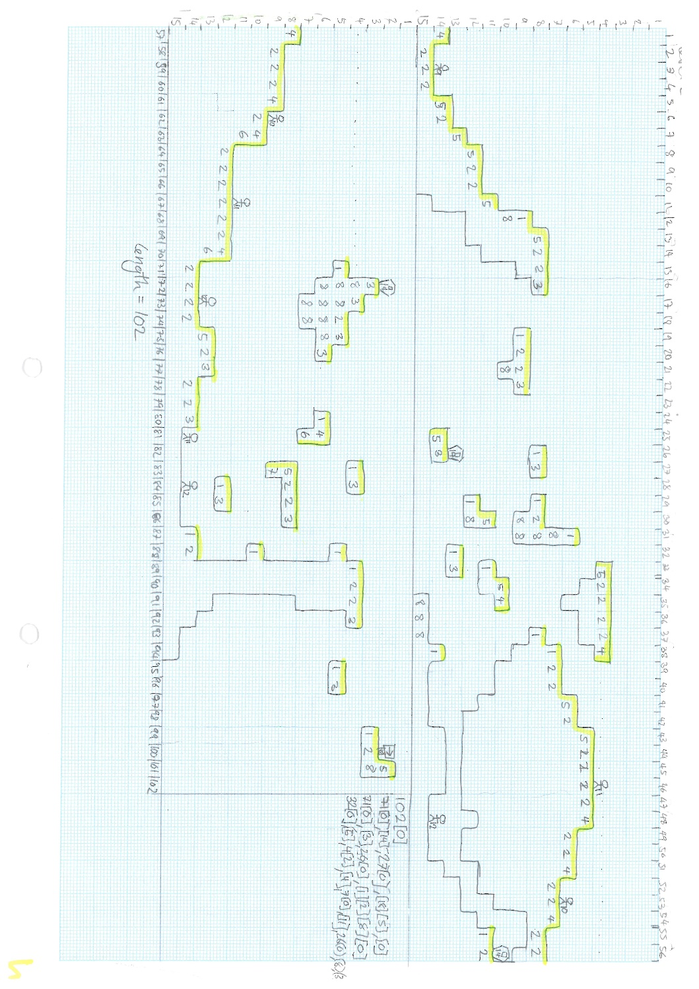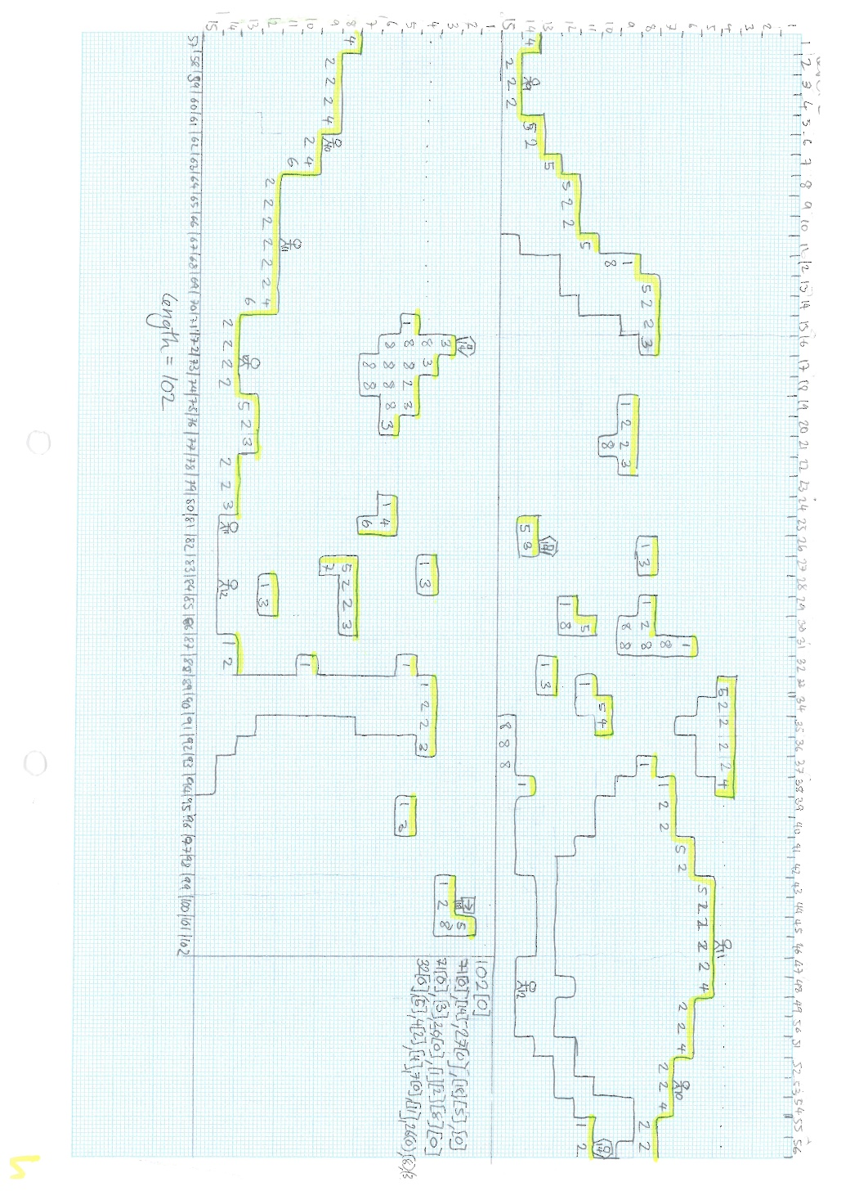

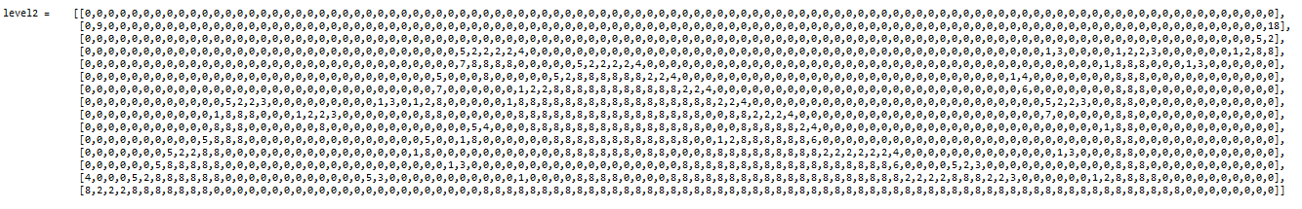

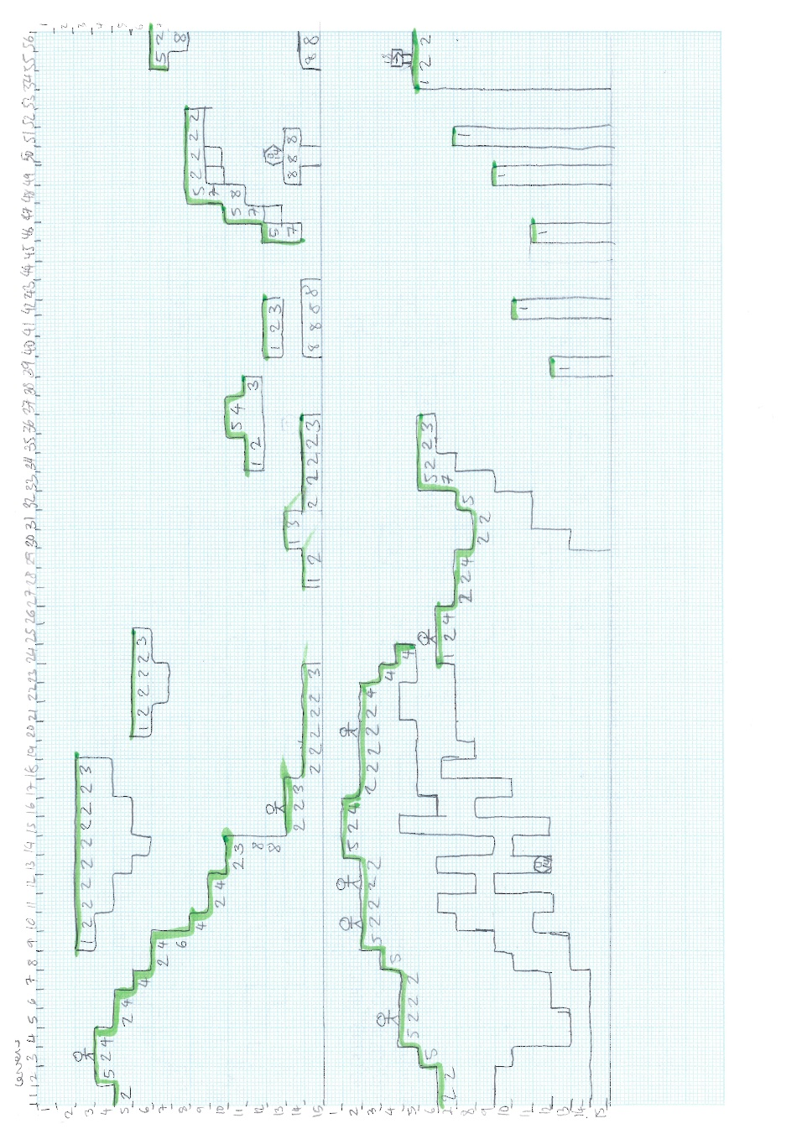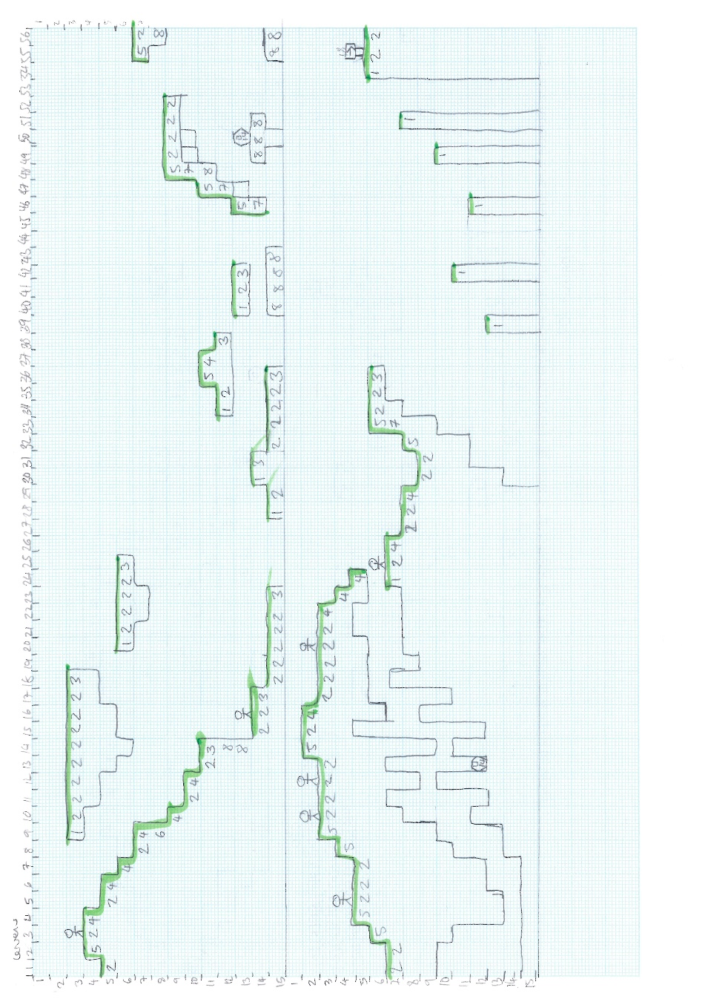

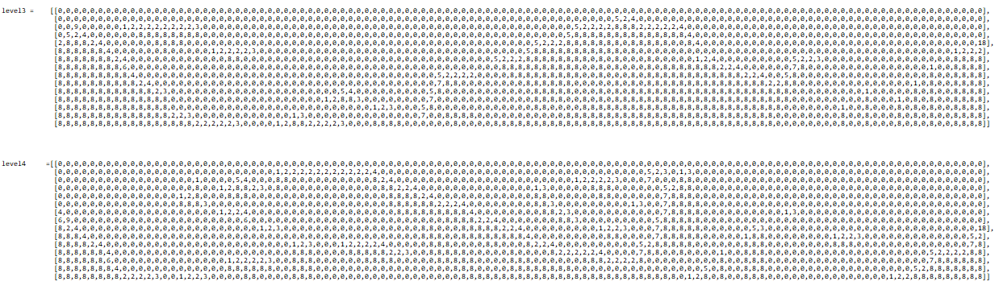

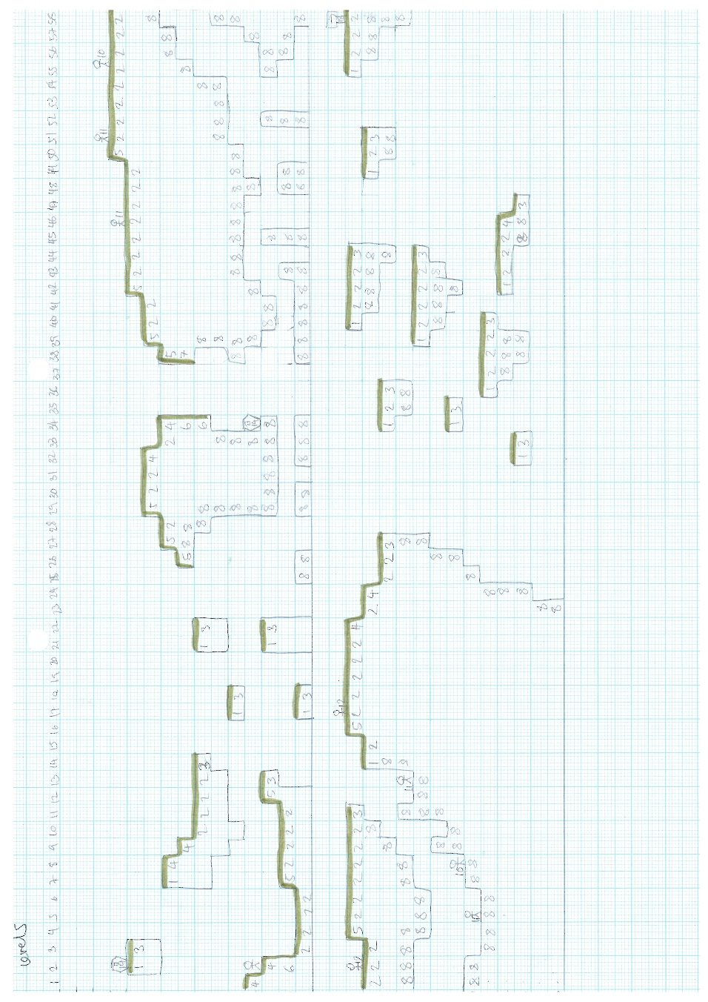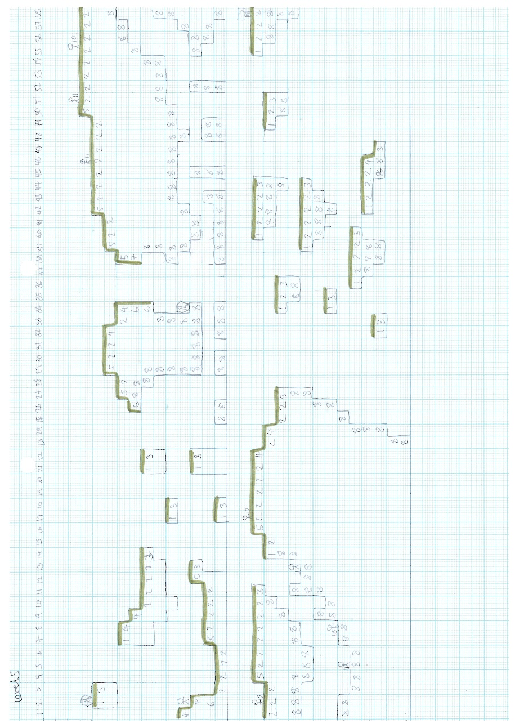



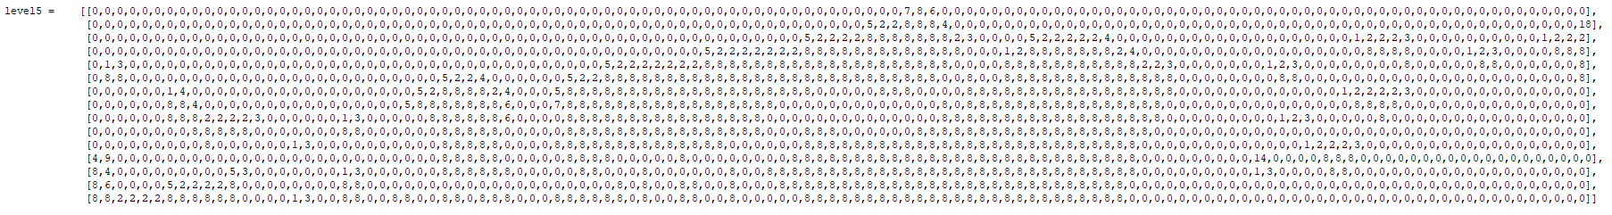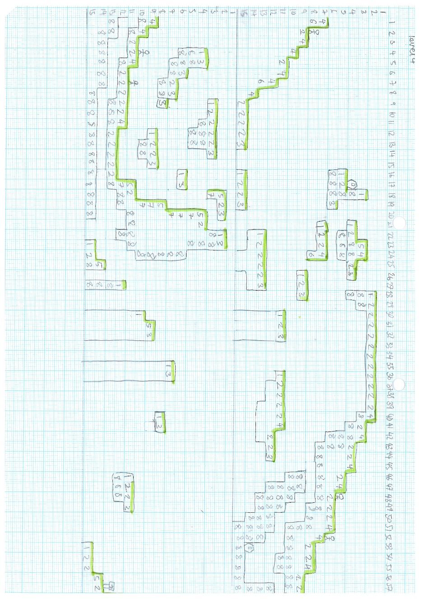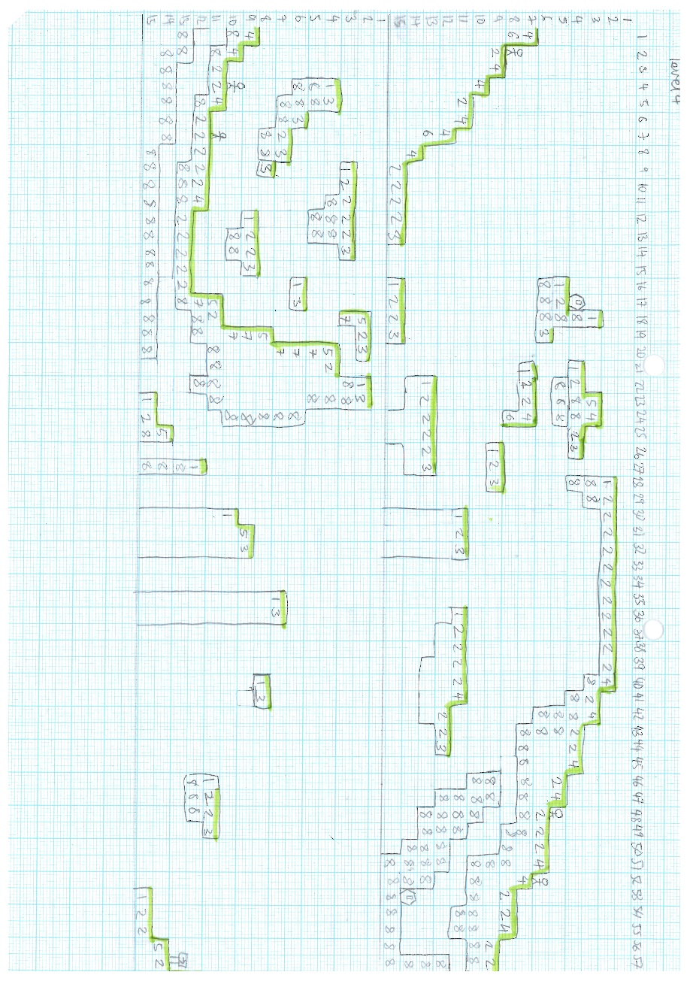

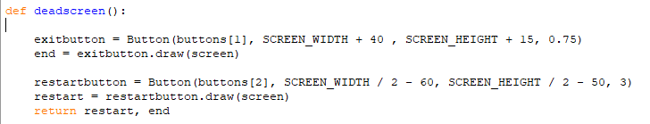Dead Screen, Game Beaten, Level Completed:

This subroutine is called when the player dies. It creates an exit button object using the Button class. It passes the button image, the x and y coordinates and the scale constructor as parameters to the constructor. The x and y coordinates are so that the button appears on the bottom right of the screen, I had to test a few different placements by changing the coordinates before I got a placement on the screen that I liked. Then the draw method is called to render it onto the screen and the output of if the button has been clicked is returned into the variable end. Then the process is repeated but with a restart button and it is places in the middle of the screen and the output is returned into the variable restart. Finally, both the variables end, and restart are passed out of the subroutine.

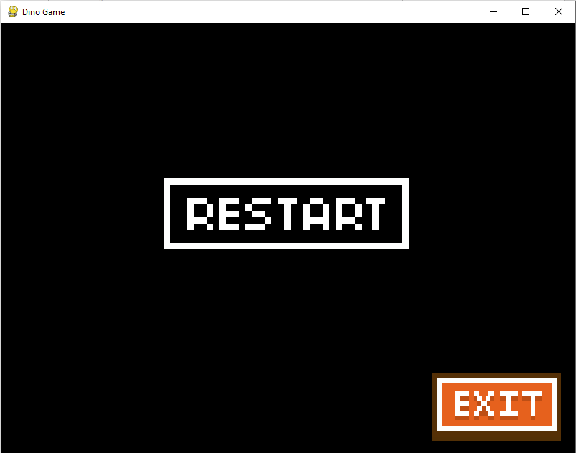

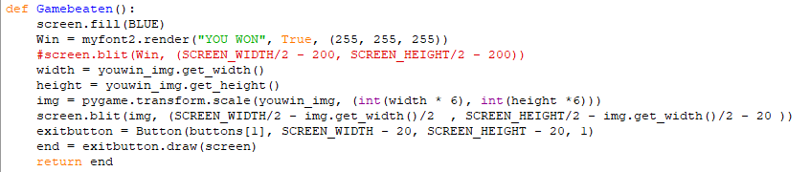

This is the subroutine called when all the levels have been beaten. First it fills the whole screen with blue and then it transforms the you won image to be a better size as the actual image is very small. It then does the same as the deadscreen subroutine and creates an exit button using the button class and then calls the draw function and assigns the output to the variable end which the subroutine itself returns.

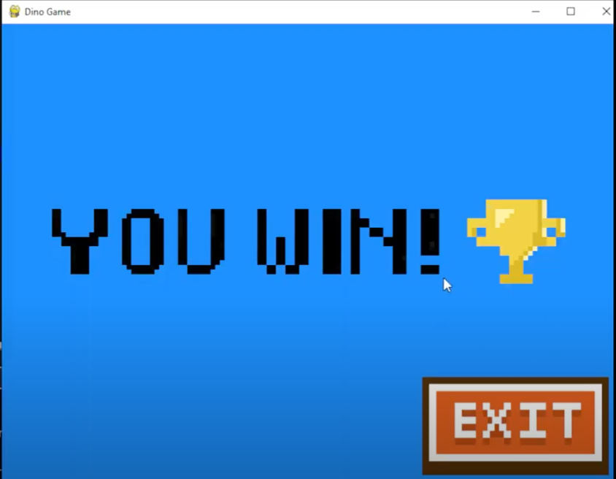

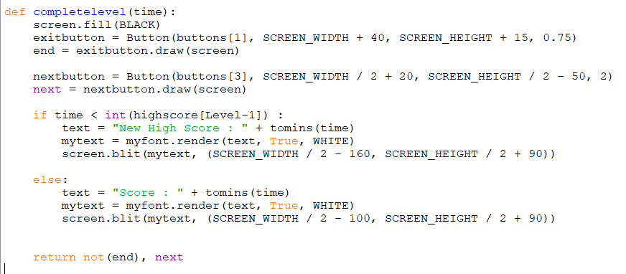

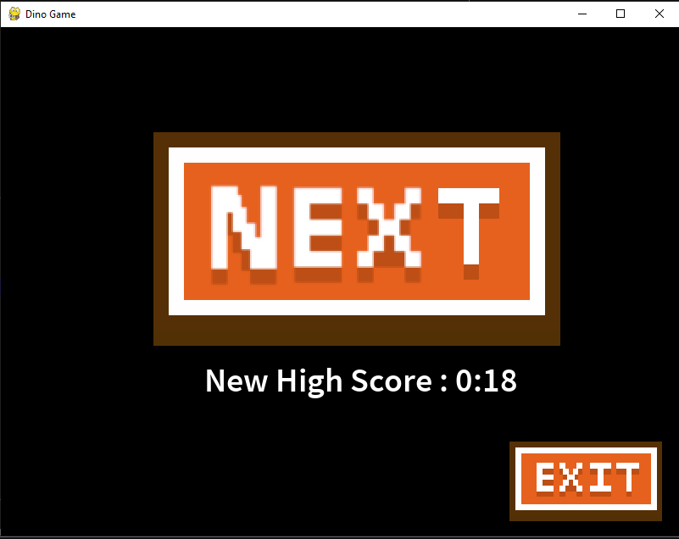This function is called when the player has competed a level. It first fills the screen with black then creates a button to be the exit button using the button class, passing in the parameters, the image of the button, which is in the list buttons, the coordinates and the scale. Then I call the draw function to render the button while also assigning the value passed back, of if the button has been pressed, to the variable end. I then repeat this with a next button used to move onto the next level, but the parameters are slightly different and the variable is called next. Then there is an if statement which creates the text to display on the screen and then renders it in the correct location. The if statement decides whether or not to print score or high score depending on if the players time is smaller than the previous high score.

Creating entity groups and Start Button:

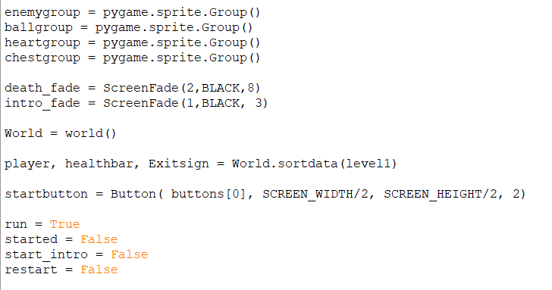

Before the main game loop a few more things need to be initialised. All the sprite groups are initialised as are the intro and death fade. The start button is also created from the button class. The first level is also created and the objects player healthbar and Exitsign are created. Finally, a few other variables including the run variable are set to their original states.

World sort data:

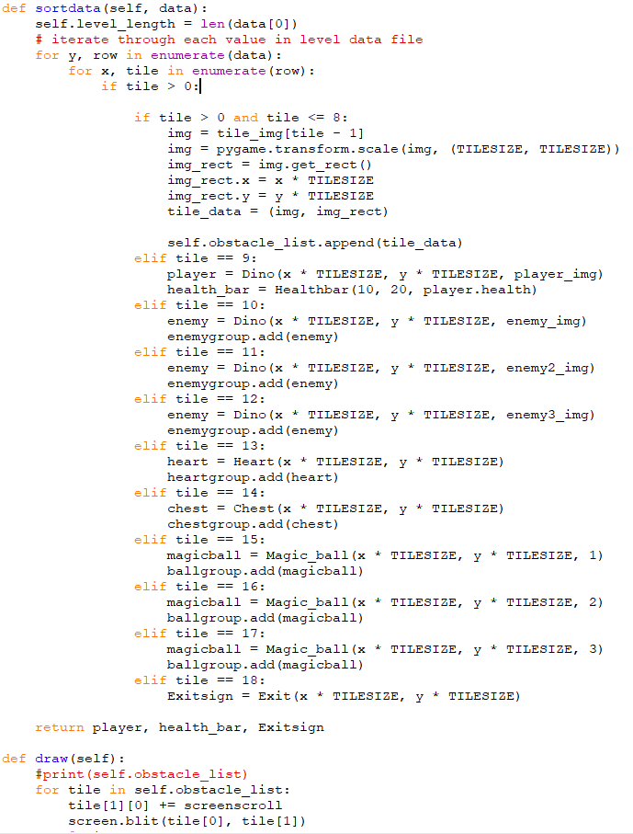

This is the world class which initialises and creates levels and also renders all the ground tiles. The method sortdata takes the level data as a parameter, it then iterates through each item in each list in the level data and if the data doesn’t represent a ground tile it will create an instance of the correct class depending on the data passing in the coordinates based on where in the iteration it is multiplied by the tile size. If it is a ground tile, then it gets the correct image and coordinates for the tile and creates a tuple which is then added to an array attribute called obstacle_list. The draw function iterates through the obstacle_list and renders each ground tile.

Screen scroll:



Screen scroll is used to make it look like the player is moving along the level when they get near the edge of the screen and is returned by calling the players move method. It is then added on to the x coordinate of everything except the player and the health bar and player stats. Bgscroll is the same as screen scroll except for the background to make it look like the background is going past when the player moves. These two lines are in the main game loop and the calling of the move method also allows the player to move.

**Dino class:**

Movement:

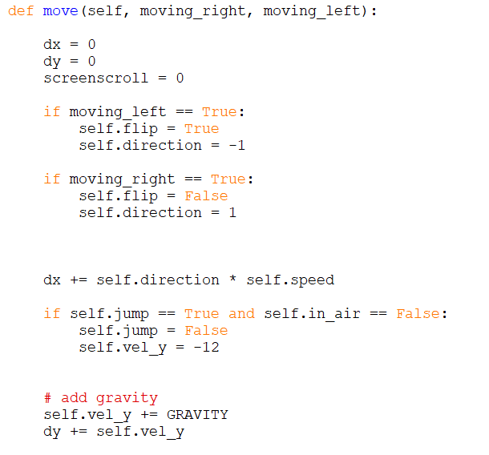

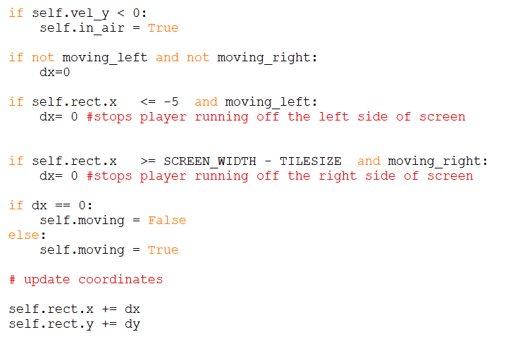

This is a method in the Dino class which allows the user to control the movement of the player and adds gravity, so the player falls if there is nothing beneath them, it takes the arguments moving_right and moving_left from the main game loop which are Boolean variables which depend on if the player is pressing the control keys to move the player. Dy and dx are local variables which determine the change in the x and y coordinate of the player and are only added on to the actual player coordinates at the end of the method. Also, self.jump is updated in the main game loop and if the player is jumping the method will set the players downwards velocity to -12 this number can be altered to make the player jump different heights. This method also stops the player running each way off the screen by comparing the x coordinate of the player to the width of the screen which is set at the very start of the program, also the player must be moving in the direction of the edge of the screen, or they will get stuck if they go up to the edge of the screen.

Player ground collisions:

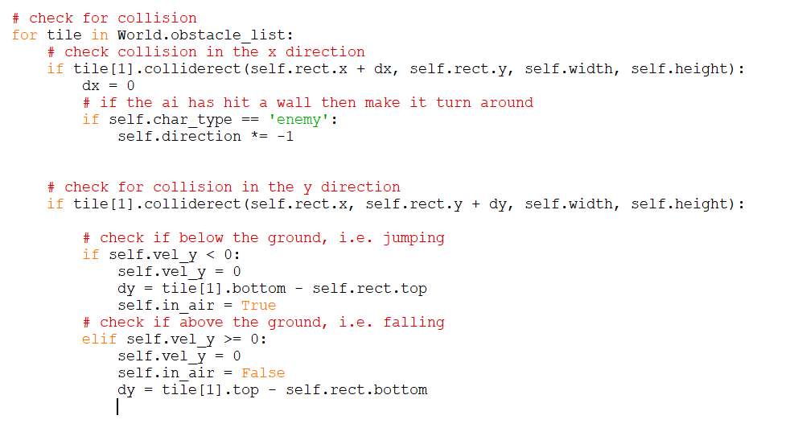

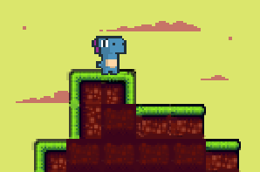This is part of the move method in the Dino class checks for a collision with the ground in both the x and y directions. It does this by iterating through the list obstacle_list from the instance of class world of the current level, this list contains all the world blocks that the player could collide with and their positions, the built Pygame function .colliderect chest for a collision with the tile in the current iteration and the player, the variables passed to this function include the coordinates of the player + dx/dy so that a collision can be detected before it happens as self.rect.x + dx is the x coordinate of the position that the player will be after this call of the move method. If there is a collision in the y direction and the player is jumping i.e., hitting their head on a tile, dy is set to correct distance between the bottom of the tile and the top of the player so the player doesn’t go inside the block. If the player is falling dy is adjusted to the distance between the top of the tile and the bottom of the player so the player doesn’t go through the block. In the x direction if the player collides with a tile dx is set to 0 so the player can’t move through the wall.

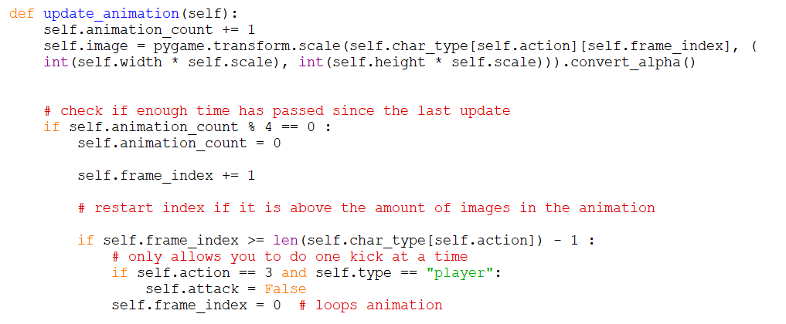Player animation:

This method is used to update the animation of the player and the enemies. The first attribute to be updated is animation_count, which is in place to control the speed of the animations as, the game runs at 60 FPS which means this method is called 60 times per second, however if the animation ran at 60 FPS it would look very fast because of the sprite animation that I found, so animation_count makes it so that the next frame of the animation is only updated every 4 times this method is run. The second and third line in this method call assigns the image of the instance of the Dino class to the new image based on the character type, action, and frame index it also calls a Pygame function to transform the image to make sure all the images are the same size.

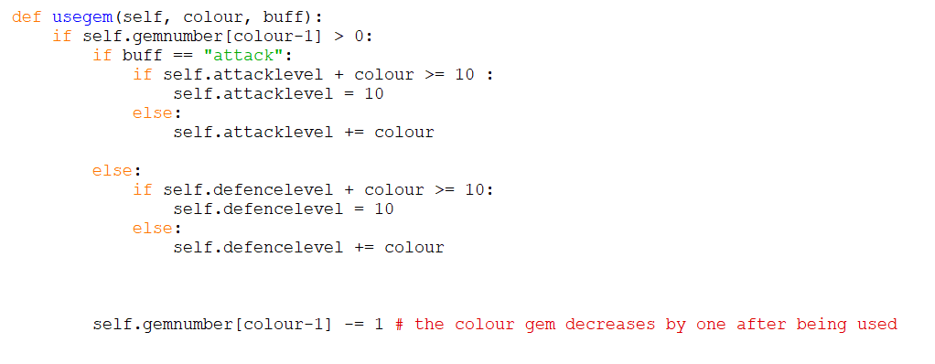Using crystals[8]:

This method is called when the user presses 1, 2, 3, 4, 5, 6 and is passed the colour and the thing that the player wants to use it on. It then applies the effect of the crystal on the specific stats (attack or defence) and removes the gem from the number of crystals that colour that the player has.

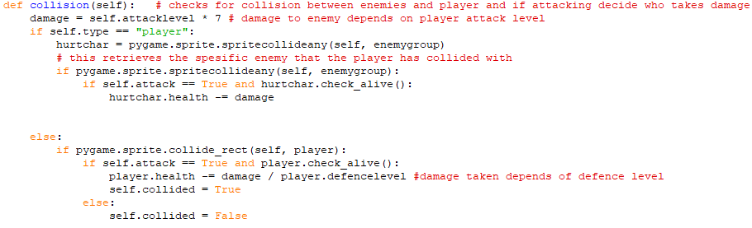Player enemy collisions:

This is the method in the Dino class that checks for collisions between the player and enemy. It uses a built in Pygame function sprite.spritecollide any if it is the player as it checks for a collision with all the enemies in the sprite group enemy group, this function also returns the specific sprite that it has found a collision with hence the variable hurtchar. It then checks if that the player is attacking, and the enemy is alive then the player does damage to the enemy. The amount of damage done is set at the start of the method and depends on the attack level of the player. If the instance calling this method is an enemy, it checks to see if the enemy is attacking, and the player is alive and if both are true then the enemy does damage to the player. This damage depends both on the enemy’s attack level and the players defence level.

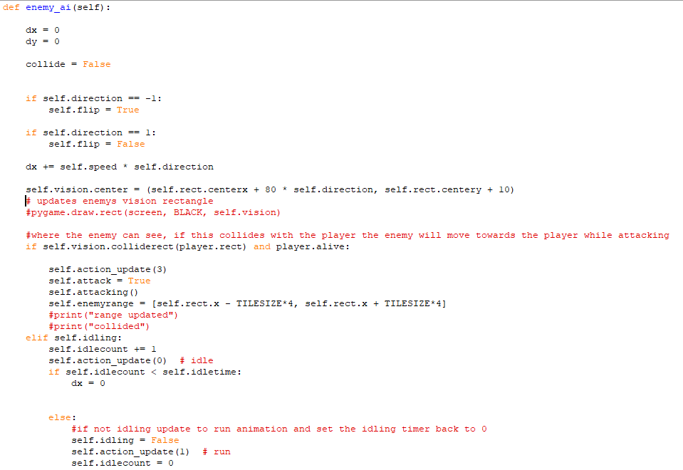Enemy ai:

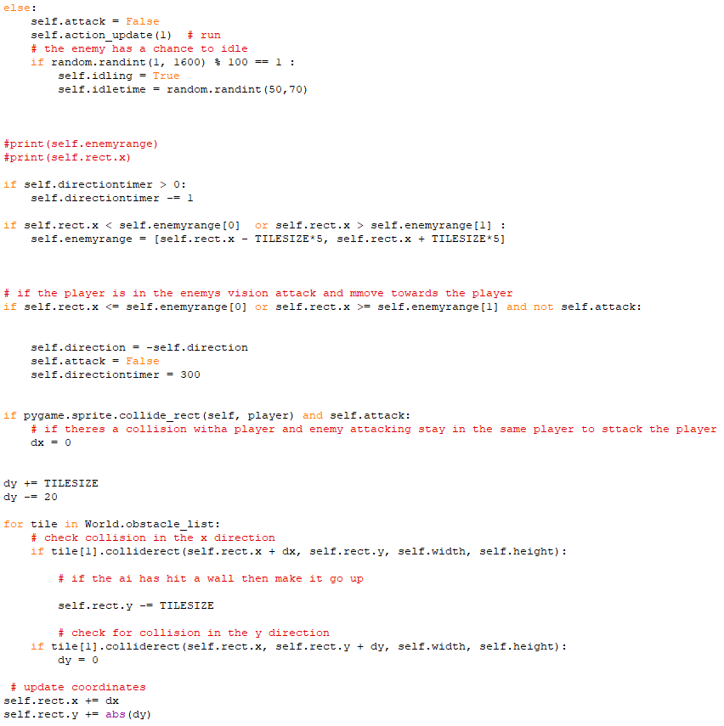

This is the method used to control the enemy movement first it sets dx (change in x coordinate) to the enemy speed * direction. In the class initialising method, each enemy is given an attribute called vision which is a rectangle which is the same direction that the enemy is moving in, however it is not rendered, the position of the vision is updated as the enemy moves, so the rectangle moves with the enemy. There is a check for a collision between this rectangle and the player to see if the player is in the enemy’s range or if the enemy can “see” the player. If there is a collision the enemy starts attacking and moving towards the player.

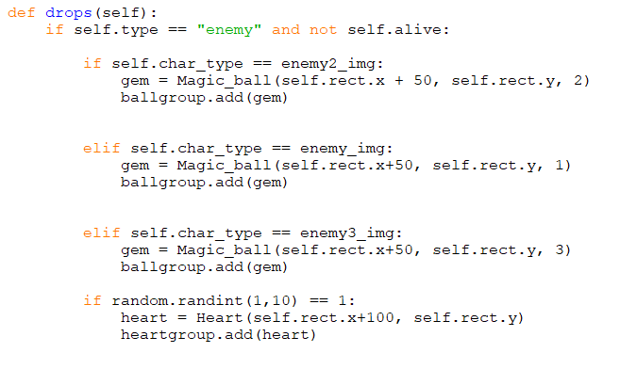Enemy drops:

This method is used when an enemy dies. It identifies which level enemy died based on the char_type attribute, and then it creates the correct colour of gem accordingly by creating an instance of the crystal class, which it passes the colour of the crystals and the enemy’s last y coordinate and x coordinate + 50 so that the player doesn’t instantly pick it up, it then also adds the instance to the Pygame group of crystals so that it will be updated and rendered in the main game loop. Also, when an enemy dies, there is a 1 in 10 chance that it will also drop a heart. This is controlled by the last if statement where it generates a random number between 1 and 10 and if it is a 1 then it creates an instance of the heart class and passes in the enemy’s last y coordinate and x coordinate + 100, so that it isn’t in the same place as the crystal.

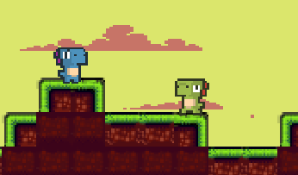

**Other OOP Classes (crystal, chest, heart, health bar, button, screen fade):**

Crystal Class:

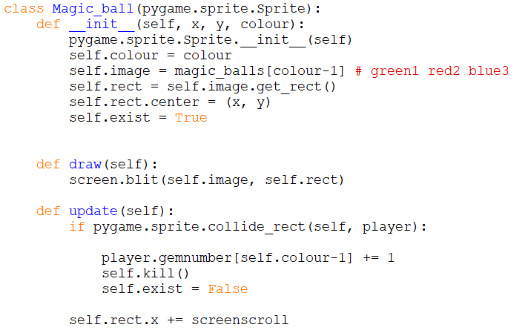

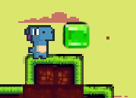

This is the crystal class, it consists of a constructor, which assigns all the attributes, including the colour of the crystal represented by a number 1, 2 or 3 and the coordinates which get passed to the constructor. The **constructo**r also creates a rectangle for the crystal, which is used to detect collisions and is built into the Pygame sprite.Sprite class which this class **inherits**. Also, the image attribute is assigned from a list of crystal images, depending on the colour attribute. This class also has the methods; draw, which renders the crystal on the screen when called, and update, which uses the built in Pygame function sprite.collide_rect() which checks for collisions between two objects which **inherit** the sprite class, which is **inherited** by the Sprite class, hence sprite.Sprite, this detects if there has been a collision between the player and a crystal. If there has been a collision, then the players number of the specific colour of crystal is incremented by one and then the .kill() method, inherited from the sprite class, is called which removes the crystal from all Pygame sprite groups which stops it from being updated or drawn.

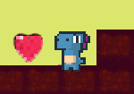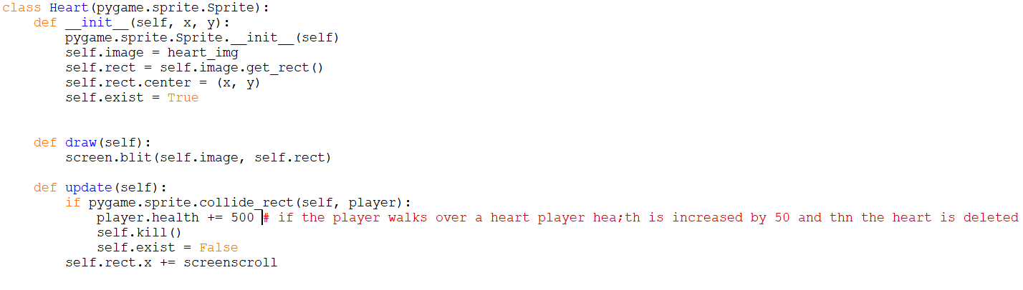Heart Class:

This is the heart class; it is pretty much the same as the crystal class. The main difference between the two is the update method where the heart class checks for a collision with the player and if a collision is detected then the players health is increased by 500 and then the heart is removed from all sprite groups using the .kill() method inherited from the sprite class

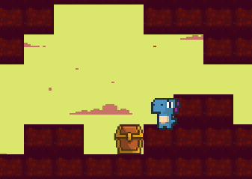

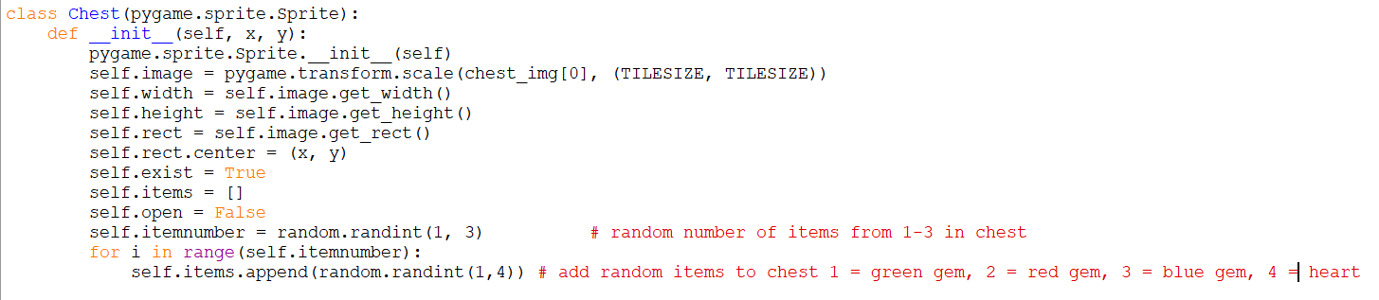Chest Generation:

This is the constructor of the chest class, it is very similar to the constructor for the crystal class, however at the starts it uses the .transform.scale() function to make the image the same size as a tile in the game so it fits with the level. Also, at the end of the constructor an attribute list called items is assigned all the items the chest will contain and that need to be created when the chest is opened. I do this by generating a random number from 1-3 (itemnumber), this is the number of items in the chest. Then I used a for loop, which runs for the number of times that there are items in the chest and each time it appends a random number from 1-4 to the items list attribute. Each number from 1 to 4 represents a different colour crystal or heart. The Chest class also has a draw method the same as the Crystal class to render it onto the screen.

Chest Player Collision:

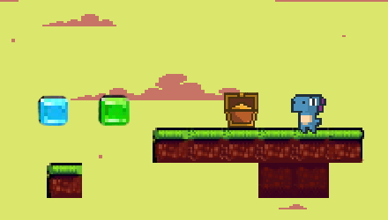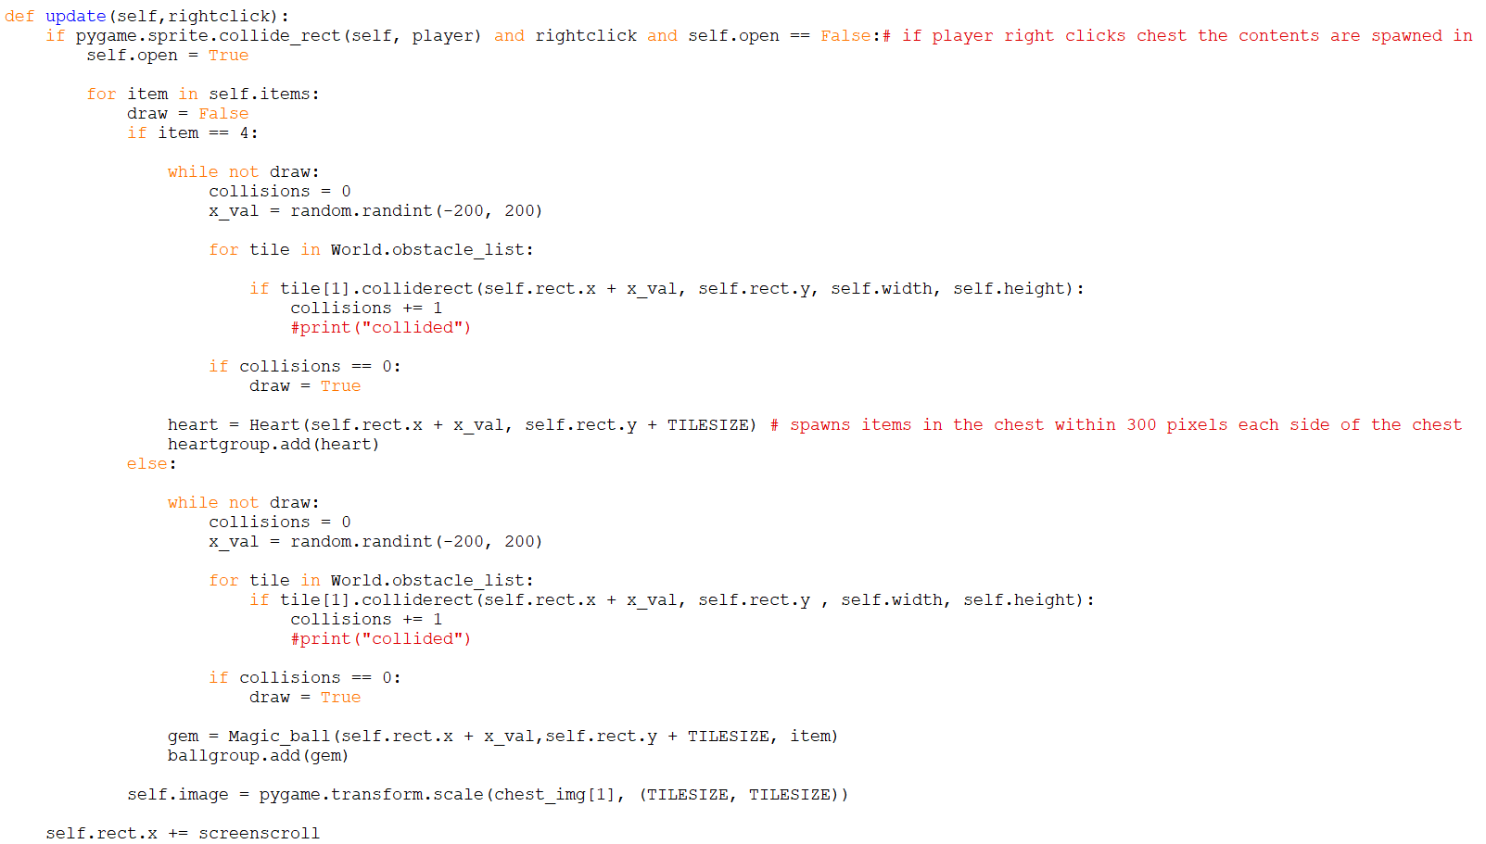

This is the update method in the Chest class, when it is called it needs the argument rightclick which is assigned in the main game loop depending on if the user is right clicking their mouse or not. The first if statement makes sure that the player is right clicking to open the chest and has collided with the chest and the chest hasn’t already been opened. If this is all true, firstly it sets the attribute open to true so it can only be opened once, then it proceeds to loop through the items list attribute, I then start a while loop with the condition draw which depends on if the item has found a place to be rendered that doesn’t collide with any of the world tiles. It then generates a random x coordinate within 200 pixels of each side of the chest, it then uses a for loop to loop through every ground tile and checks that it won’t collide with the tile, this is so that it won’t be inside the ground where the player can’t get to it. If there is a collision, the variable collisions is incremented. If collisions = 0 then draw is set to true to break out of the while loop and if the item number is 4 an instance of the heart class is created at the correct coordinates just generated. If the item number is 1, 2 or 3 the correct colour crystal is created using the crystal class. At the end of this method the image is updated to an image of an empty chest, which is also transformed to be the same size as a world tile.

Health Bar:

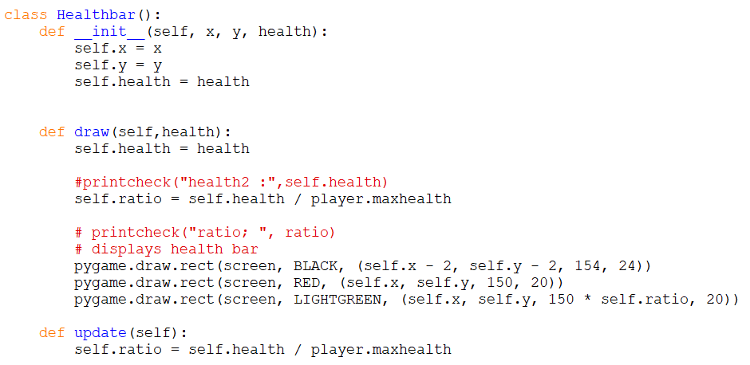

This is the health bar class; the constructor takes the x and y coordinates and the health of the player as arguments and assigns them as attributes. The draw method updates the health of the player which is once again passed as an argument to the method. Then it finds the ratio of the players current health to the players maximum health. After that, 3 rectangles are drawn; a black one to outline the other two, a red one which stays the same size, and a green one who’s length depends on the ratio calculated earlier multiplied by the length of the red rectangle. This appears that the players health is in green and the health that the player has lost is in red and both are outlined by a black line which is actually a black rectangle that has been rendered underneath both the red and green rectangles.





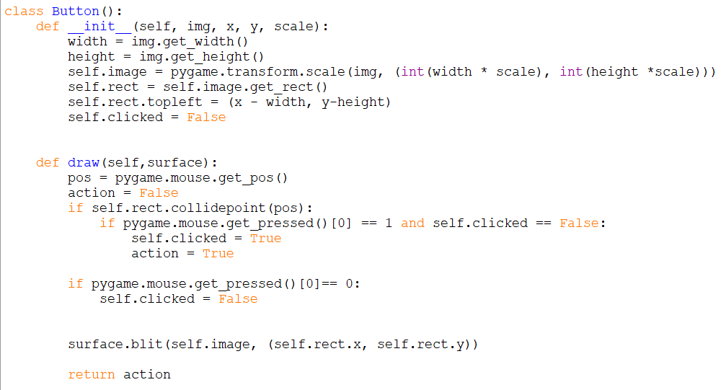Button Class:

This is the button class, I created it to be able to put buttons on the screen and get back whether they have been clicked or not. The constructor takes the arguments; the image of the button, the x and y coordinates of the button and the scale so I can change its size. The draw method uses Pygame to get the position of the mouse on the game window, then sets action to false. I then use an if statement and a Pygame function to see if there id a collision between the mouse and the button, then I use another Pygame function to check if the mouse has been right clicked and if it has and it also hasn’t already been clicked then action is set to true and clicked is set to true, this makes it so that the button can only be used again if it is unclicked by a left mouse click. Lastly it renders itself onto the screen and returns action so you can tell if it has been clicked outside the method.

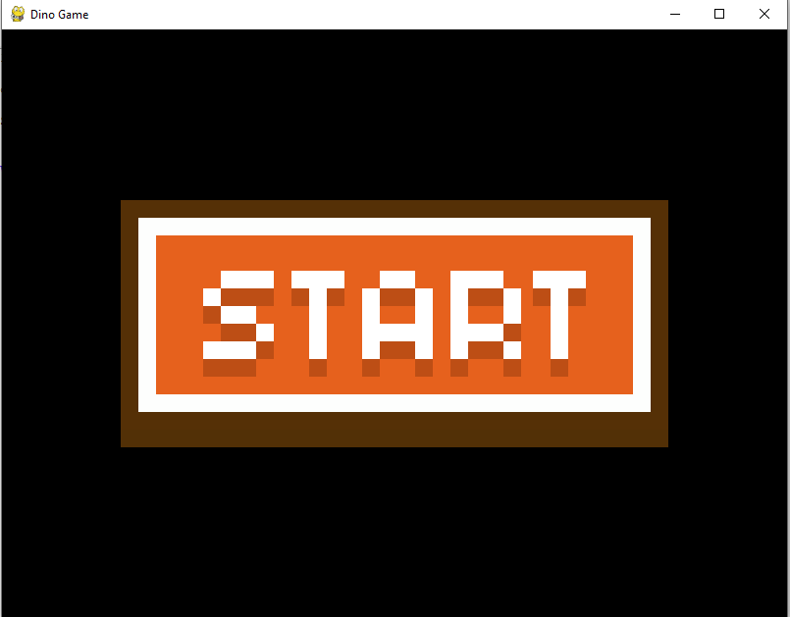

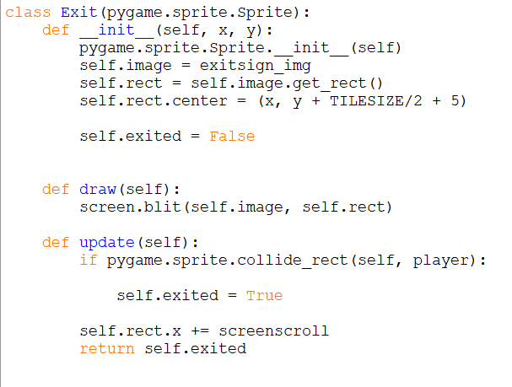Exit Class:

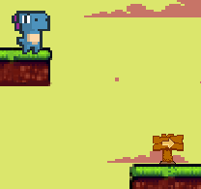

This is the Exit class which is what the player needs to stand on to complete the level. The x and y coordinates are passed in as arguments to the constructor which also assigns the image which is loaded in at the start of the program. This class also **inherits** class sprite.Sprite so that I am able to use the collision detection methods included in this class. The draw method renders the exit sign on the screen and the update method checks for a collision with the player and then returns the results of if there has been a collision or not in the attribute exited.

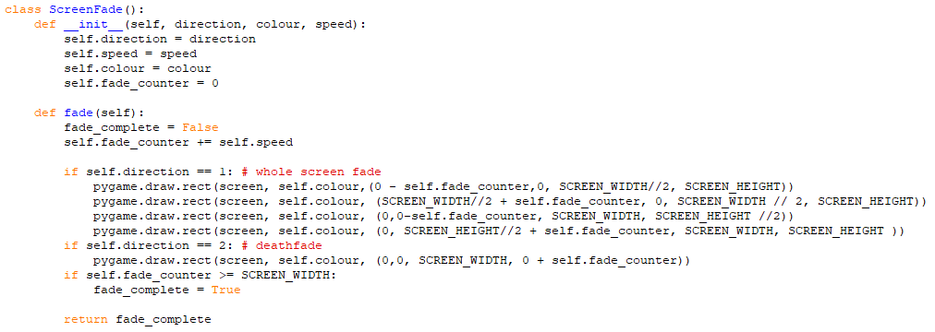Screen Fade Class:

This is the Screen fade class, and it is used for screen transitions for example at the start of each level or when the player dies. The arguments that the constructor takes are the direction (1 or 2) the colour and the speed. The only method it has is the fade method where what it does depends on the direction attribute. At the start of the method the fade_counter is incremented by the speed. If the direction is 2 then it is the death fade where a rectangle comes down over the screen and its height is altered by the fade_counter. If the direction is 1 then it is the start of level fade which had four rectangles originally covering the entire screen and they slowly move off the screen revealing the level. These rectangles positions are also altered by the fade _counter. After this it checks whether the fade_counter is greater than the screen width and if it is it sets fade _complete to true and returns it so that the fade doesn’t keep going forever.

**Timer:**

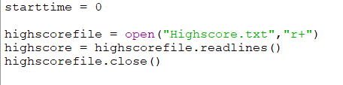Reading and writing the high score test file:

This is at the very start of the program underneath assigning all the global variables. Start time is set to zero. I then open the Highscore.txt file in read more indicated by the parameter r+ and then I create a list called highscore by using the readlines function which returns all the lines in the text file in a list, where each line is an item in the list

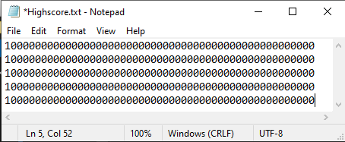

This is a screenshot of the starting text file, where the high score for each level is stored on each line and the high scores are all set to a very big number to ensure that the first time the player completes a level, they get a highs core as it is almost guaranteed to be smaller than the extremely large number. Also, the times are stored in milliseconds as it is the Pygame default, which makes it easier to work with

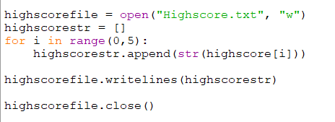

This code is at the very end of the program after the main game loop so that the high scores are stored right before the program closes. First, I open the Highscore.txt text file in write more indicated by the parameter w and I create an empty list called highscoresrt so that I can append things to it. Then I have a for loop that runs 5 times as there is 5 levels where each item in the list highscore is converted into a string, as it needs to be a string to be written to a text file and then it is appended to highscorestr. Then I use the writelines function, which takes a list argument and writes each item of the list onto a new line, to write the new high scores to the text file. Lastly, I close the text file

Starting and ending timer:

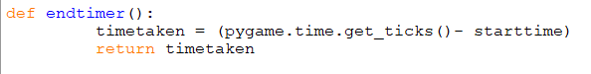

This is the function endtimer which finds the amount of time between the start of the timer (starttime) and the time elapsed since Pygame started running which is retrieved by the function Pygame.time.get_ticks() the value returned by this is in milliseconds.

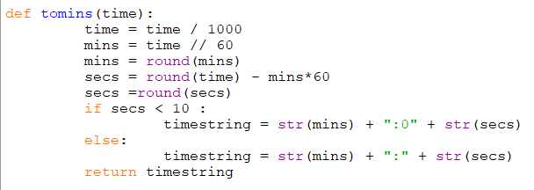Converting milliseconds to minutes and seconds:

This function takes an argument of time in milliseconds, which is the Pygame default units for time, and it converts it into a string with minutes and second. I first convert the time to seconds by dividing by one thousand and then get the minutes by using the DIV function which is // on the time. I then find the seconds by doing the time minus the number of minutes times 60, then I round the seconds to a whole number using the Python function round. Finally, I created the time string with and if statement, which if the number of seconds is less than 10 adds a 0 to the front of the string before the colon, both parts of the if statement create a string of the time in the format of a digital clock so that I can display it on the screen.

Displaying the timer on screen:

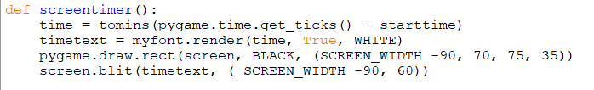

This function displays the timer on the screen by first getting the time elapsed from the start time and passing it into the tomins function to get the time in a digital clock format. The I created the Pygame text in my font which I assign at the very start of the program, and I pass in the time and the colour, white, then I render it, by first rendering a black rectangle underneath, using the Pygame draw function, so you can see the white text and then the text on top of the black rectangle. Then I render the text on top by using the Pygame function blit and passing in the text and the coordinates.

**Main game loop:**

The main game loop starts with if run = true: so that the game will continue running until the player closes out of it by doing something that changes the variable run to false

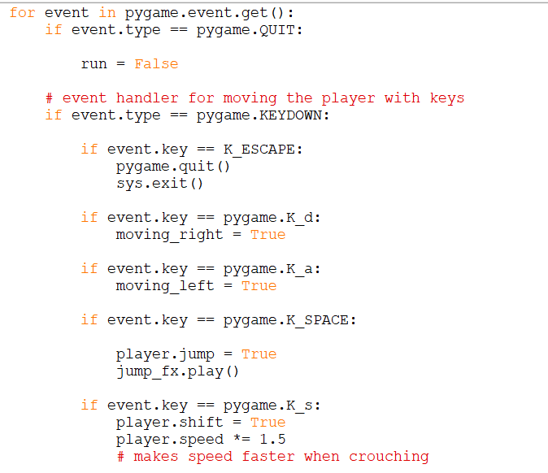User Input from keyboard (key down / key up) and mouse clicks:

The first few lines of code in this screenshot loop through events in Pygame and one of the types of events is quitting the game by pressing the cross at the top of the screen as is the same for most programs, so if this event is detected the game variable run is set to false so that the main game loop stops running. If the event type is keydown, which means that the user has pressed a key on the keyboard. Inside this if statement there are other if statements that check for the relevant keys to be pressed. If the user presses escape the function .quit() is used to close the game, making pressing escape another way to close out of the game. If the user presses the d key, then the variable moving_right is set to true as this is the control key to move right. If the key a is pressed, then moving_left is set to true as a is the key to move left. If the user presses the spacebar, then player.jump is set to true as the spacebar is the control for jumping, also the sound effect for the player jumping is played. If the key pressed is s, then the players speed is multiplied by 1.5 as this is the control to make the player sprint.

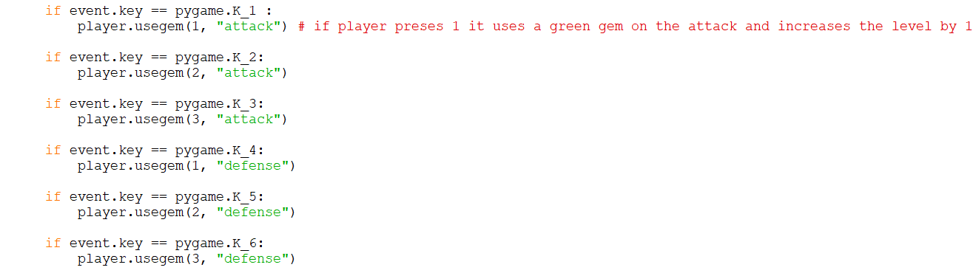

This is a continuation of the previous for loop that gets events in Pygame and the if statement that says if the event is a keydown. If the user presses 1 then the method usegem() from the player object is called, and it passes in the colour of the crystal (green is 1, red is 2, blue is 3), and the statistic that it will be affecting, in this case the players attack level. This repeats with keys 2-6, with keys 1-3 being the keys to increase attack level and 4-6 being to increase the defence level.

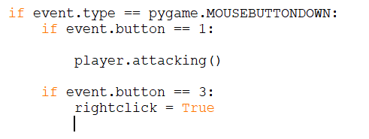This is still in the for loop of Pygame events, however this event is called a mousebuttondown, which means that the user has clicked a button on the mouse, if this button is 1 it indicates a left click and so the attacking method from the player object is called as this is the control to attack. If the button is 3 that means that it was a right click and the variable rightclick which is used in the chest class is set to true

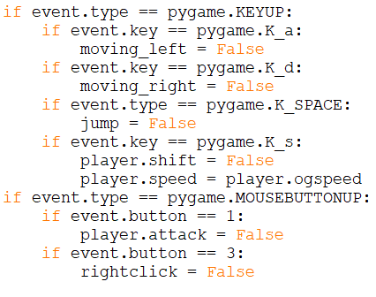

The next event the for-loop checks for is a keyup event which means the user has stopped pressing a key, these are all the same keys as the previous ones except the numbers and they set their respective variables back to false or in the case if key s set the players speed back to the original speed. The next event is mousebuttonup which is the opposite of mousebuttondown (which is when the mouse is clicked), and it sets the respective variables back to false as the player is no longer clicking the mouse button.

Calling methods from classes:

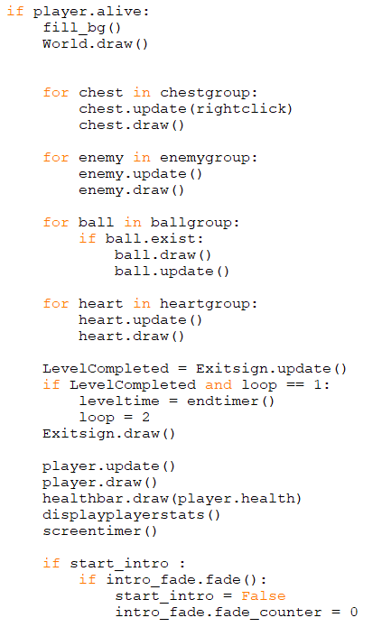

This is a big if statement in the main game loop which calls all the methods from the classes so that everything gets rendered on the screen. The background is the first thing to be rendered as it is at the back, then the world is rendered. Then for each sprite group there is a for loop which updates and renders all the objects in each group this makes sure that the objects that don’t exist anymore aren’t updated or rendered as when they cease to exist, they are removed from all sprite groups by the Pygame .kill() method inherited from the sprite class. Then there is an if statement which checks if the level has been completed and if the variable loop = 1 and if it does then the variable level time is assigned the amount of time it has taken for the player to complete the level and the variable loop is set to 2. The purpose of the variable, loop, is so that the if statement can only be true once per level otherwise the time to complete the level continues increasing when the player is on the level competed screen. The variable loop is set back to 1 when the next level is started. The exit sign to go to the next level is also updated and drawn and the update method returns whether the player has completed the level or not and if they have then the Level variable is incremented by one. Then the player is updated and drawn as needs to be seen on top of everything else. Lastly the health bar and the player stats and the timer are rendered, this is so the everything goes underneath the health bar and the player stats and the timer so that if there is a bit of the level that is high up on the screen the user can still see the players health and stats and timer. After this you can see there is an if statement that controls the intro fade. If the variable start_intro is true, then the .fade() method is called on the intro_fade object and as well as animating the intro fade this method also returns if the fade is compete, so there is another if statement to set the start_intro variable to false when the inro fade is finished, finally the intro_fade’s fade counter is set to 0, so that it can be used again on the next level.

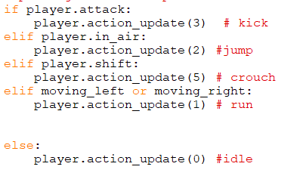Updating player actions:

This is in the if player is alive statement and it updates the action of the player so that the animation can be corrected to what the player is doing. This kick action update is before the jump so that the player can kick while in the air and jump is above crouch so that the player can’t crouch while jumping. If no other actions are going on the player action is updated to idle.

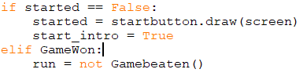Start Screen and Game Beaten:

This is at the very beginning of the main game loop so that when the game first starts a start button is rendered onto the screen and stays there until the user clicks start. The other option for this if statement is if the game is won the Game beaten subroutine is called which has a button to exit the game and is returned from the subroutine as the opposite of the run variable. If the subroutine returns that the exit button has been pressed, then the program will close. There is also an else at the end of this if statement where most of the rest of the main game loop code is.

Restart and Level completion:

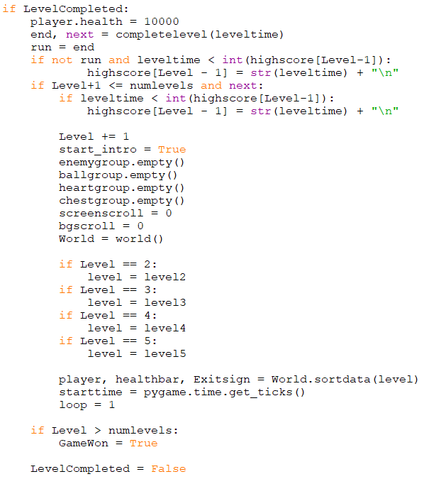

If the level is completed which is dictated by a variable that is returned by the update of the exit sign, player health is set to 10000 so that the player can die to enemies as the level is still running, then the complete level subroutine is called which displays the time it took to complete the level and an exit and next button, it then returns if the buttons have been clicked. If the exit button has been clicked the variable end will be false which the run variable is assigned and if run is set to false and the time to complete the level is smaller than the current high score the high score is changed. Then it checks if the level is smaller than or equal to the number of levels and if the player has clicked the next button which is passed back through the variable called next, if it is then it checks if the time to complete the level is smaller than the current high score and if it is, then high score is changed. Then start_intro is set to true which plays the intro fade. Then it empties all the sprite groups to kill all the current sprites and then it creates a new object called world which overrides the old-world object. Then it checks to see which level needs to be rendered next and then runs the sort data method passing in the correct level and that passes out new player, health bar and exit sign objects which override the old ones which were previously being used on the last level. It then checks if the Level is greater than the number of levels which means the player completed the game and sets the GameWon variable to True so that on the next iteration of the game loop the winning screen will be shown.

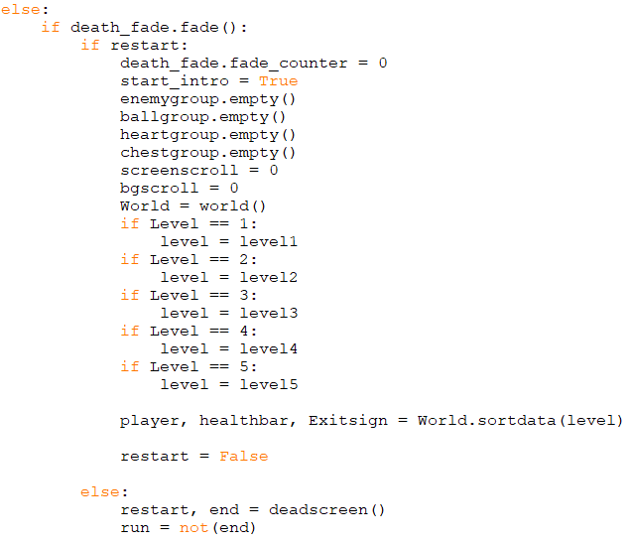This section runs if the player has died. It calls the fade method on the death_fade object which returns if the fade has finished, to make sure the previous death fade has been competed and then checks if the variable restart is true and then proceeds to do the exact same thing as the level completed if statement does and then set restart to false at the end. If restart is false, then to subroutine deadscreen is called and it returns restart which is whether the user has clicked the restart button and end which is if the player has clicked the exit button. Then run is set to the opposite od end so that if the user clicks the exit button the game will close.

**References:**

To help me get familiar with the Pygame module that I was using I looked up a few tutorials and took inspiration from them, these helped me get familiar with the specific syntax that Pygame adds into Python and helped me with some of the ideas for the classes in my project.

<https://coderslegacy.com/python/pygame-rpg-game-tutorial/>

<https://www.youtube.com/playlist?list=PLjcN1EyupaQm20hlUE11y9y8EY2aXLpnv>

https://github.com/russs123/Shooter

<http://codingwithruss.com/pygame/shooter/music.html>

https://www.pygame.org/docs/ref/time.html

# **Testing**

For this section most of my testing evidence is in video form on YouTube as there is no way to show that it works through a screenshot. I will refer to time stamps in this video to show different things.

The link for the video is https://youtu.be/W2LBu7dsKmY

|  |  |  |  |  |  |
| --- | --- | --- | --- | --- | --- |
| **Category** | **Test objective** | **Method of testing** | **Expected Outcome** | **Test passed?**  **(Yes/No)** | **Time(s) seen in Video /Evidence** |
| Player  1.0 | Test that the player controls work | Use all the controls (A, S, D, Space, left click) | Player should go forwards backwards and jump using A, D, Space and sprint with S, and attack with left click. | Yes | 0:09* |
| 1.1 | Test that the player animations work | Use all the controls (A, S, D, Space, left click) | For each action the corresponding animation of the character should show | Yes | 0:09* |
| 1.3 | Test that the player can attack and do damage but not spam click | Attack an enemy by spam clicking then attack enemy with timed clicks | If the player spam clicks the enemy shouldn’t die but if the player times the attacks, it will do damage and kill the enemy. | Yes | 0:33* |
| 1.4 | Test that respawning works | Die with crystals | The player will be able to click the reset button and reset the level with the base number of crystals and stats. | Yes | 4:40* |
| 1.5 | Test that the crystal numbers, health bar and stats update | Pick up crystal, use crystal, get attacked by an enemy | When the player picks up a crystal the number of crystals of that colour should go up by 1. If the user presses the correct button to use a crystal the number of crystals should go down by one and the correct stat should go up by the correct number depending on the colour of the crystal. If a player gets attacked by an enemy the health bar should go down | Yes | 0:23*  0:35*  0:32* |
| Enemies  2.0 | Test that all enemies can damage the player and that different enemies do different amounts of damage based on the level/colour of the enemy | Get attacked by different level enemies | The player health bar should go down by different amounts depending on the level/colour of the enemy that the player gets attacked by | Yes | 0:22*  0:32* |
| 2.1 | Test that the player can kill enemies | Attack an enemy | The enemy should die | Yes | 0:33*  2:17*  2:24* |
| 2.2 | Test that enemies drop the correct colour crystal after being killed | Kill an enemy | The enemy should drop the correct colour crystal for its level | Yes | 0:33*  2:17*  2:24* |
| 2.3 | Test that enemies don’t respawn after being killed | Kill an enemy | The enemy should not respawn | Yes | 0:33* |
| Crafting  3.0 | Test that the player can use crystals to increase their level of attack or defence | When the player has a crystal, press the correct number on the keyboard to use it | The number of crystals of the specified colour should go down by one and the attack or defence stat should go up by 1, 2 or 3 depending on the colour of the crystal being used | Yes | 0:35*  0:56* |
| 3.1 | Test that the amount of attack damage done increases as the attack stat increases and the amount of damage done by enemies decreases when the defence stat increases | Attack an enemy, then attack and enemy of the same level with a higher defence stat. Get attacked by and enemy, get attacked by the same level enemy with a higher defence stat | The first instance the player should be able to kill the second enemy with less hits. The second instance the player should take less damage from the second enemy than from the first enemy | Yes | 0:32  0:51  0:32  1:55 |
| 3.2 | Test that a player can’t increase a stat without having the crystals to | Click the buttons 1-6 on the keyboard while the player has no crystals | The number of crystals of each colour should not increase | Yes | 0:09 |
| 3.3 | Test that the attack level and defence level can’t go above 10 | Try to use crystals on an attack or defence stat while it is already 10 | The number of crystals should go down, but the stat should stay at 10 | Yes | 2:13  * |
| Chests and Drops  4.0 | Test that chests spawn on the map | Walk to an area where there should be a visible chest | The chest should be in the game | Yes | 0:20* |
| 4.1 | Test that the chest image changes to open when it is opened | Right click on a chest to open it | The image of the chest should change to an open chest | Yes | 0:22* |
| 4.2 | Test that when opened chests contain 1-3 random crystals or hearts | Open a chest by right clicking on it | The chest should spawn 1-3 random items when opened | Yes | 0:22* |
| 4.3 | Test that chests can only be opened once | Open a chest then try to open it again | The chest should open the first time then nothing should happen the second time | Yes | 0:22* |
| 4.4 | Test that hearts restore player health and disappears when picked up | Pick up a heart while not on full health | The player health bar should go up and the heart should disappear | Yes | 0:43* |
| 4.5 | Test that when crystals are picked up, they increase the number of the correct colour crystal and disappear | Pick up crystals of different colours | The correct corresponding number of crystals should increase by 1 and the crystal should disappear | Yes | 0:23 * |
| Levels  5.0 | Test that all five levels exist | Complete all 5 levels | There should be 5 levels | Yes | The whole video |
| 5.1 | Test that each level should be a different map | Go through each level | Each level should have a unique map | Yes | 0:00  Each time I complete a level |
| 5.2 | Test that each level should be harder than the last | Play and complete each level | Each level should have more time spent on it and more deaths | Yes | Level 1 0:05 – 1:08  Completion: 1:03[9]  Deaths: 0  Level 2 1:11 – 2:37  Completion: 1:26  Deaths: 0  Level 3 2:38 – 4:26  Completion: 1:48  Deaths: 1  Level 4 4:28 – 8:37  Completion: 4:09  Deaths: 3  Level 5 8:38 – 11:12  Completion: 2:34  Deaths: 4 |
| 5.3 | Test that the player can get to the next level by making contact with the exit sign at the end of each level | Complete the level and touch the exit sign | When you touch the exit sign the next level should start | Yes | 1:07 |
| 5.4 | Test that all levels are completable | Complete all 5 levels | You should be able to beat the game and get to the winning screen | Yes | 11:11 |
| 5.5 | When the player beats the 5th level the winning screen should show | Complete the 5th level | The winning screen should show | Yes | 11:11 |
| Music and SFX  6.0 | Test that the background music plays | Start the game | The background music should fade in and then play throughout the game | Yes | 0:00-13:14 |
| 6.1 | Test the jump SFX | Jump by pressing space | The jump sound effect should play | Yes | 0:09* |
| Exporting  7.0 | Export the game as a self-running executable | Open executable file | The game should run without any issues | Yes | I do not have any screenshots of this however, I was able to run it on my home PC but was unable to test it on the school network due to restrictions. |
| Timer  8.0 | Test that the timer increases in levels | Start a level | The timer should be displayed and go up | Yes | 0:08* |
| 8.1 | Test that the timer resets if a level is restarted or a new level is started | Start a new level and die on a level and restart it | The timer should restart | Yes | 1:13* |
| 8.2 | Test that the very first time that the player completes each level they get a high score | Complete each level | After each level is completed for the first time the level completion screen should say high score as well as the time | Yes | 1:08  2:37  4:26  8:37  11:12 |
| 8.3 | Test that if the game is closed after playing once, the high scores are retained from the previous times it was played | Before starting the game open the high score text file. After finishing and closing the game open the high scores text file | The first time the text file should contain all default very large scores for each level. After the game it should contain all the scores for each level in milliseconds | Yes | Screenshot 1  Screenshot 2 |
| 8.4 | Make sure high score is only displayed when the player gets a lower time than before | Complete the game, then close it, the open it and play the levels again | If the score is smaller than the first time the game was played it should say high score and, if it isn’t it should only say score and display the score afterwards | Yes | 11:38  13:08 |

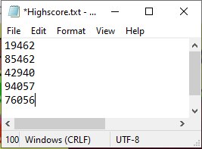

Screenshot 1 Screenshot 2

*All times with a star are instances of things that happen multiple times across the whole YouTube video, however I have just put down the very first time they happen

# **Evaluation**

**Evaluation of Original Objectives**

Player

I think that the player section of the Dino class worked out quite well as, the user can easily control the movements of the player by using the simple controls W, A, S, D, and the mouse. The player can easily pick up crystals and open chests. The player can take damage and the health bar will decrease and the player can kill enemies by attacking them. Also, the character animations worked well.

Enemies

The enemy AI is alright but could be improved. The enemies wonder around in a set area and randomly stop for a random amount to time and if they see the player, they ignore their specified area and move towards the enemy while attacking, the enemy can also go up and down tiles, which is where the problems arise. The way I programmed enemies going up tiles when there is a collision in the x direction, the code doesn’t check how high up the enemy is moving, so the enemy can go up and infinite number of tiles whereas the player can only jump two tiles high. This also created another problem with enemies in caves, when the enemy reaches the end of the cave the code detects the collision and makes it go up, when there is no exit and then the enemy keeps moving up until it is on the surface. This doesn’t take away from how enjoyable the game is to play however it may appear strange to the user. Something I thought I did well was that the enemy can only see the player if it is facing towards the player.

Crafting, Attack and Defence

The crafting works very well, when the user presses the correct key for the correct colour tile for either attack or defence, the players attack or defence levels go up on the screen and the also have effect on the gameplay as, the higher the attack level the more damage the player does when stacking an enemy, and the higher the defence level, the less damage the player takes when an enemy attacks them. The only thing I would improve about this is that figuring out the correct key to press is a bit confusing.

Chests and Drops

The chests and enemy drops work mostly as I intended them to. When a player opens a chest by right clicking, the chest image changes to an open chest and 1-3 random items. The one issue with the chests was that even though I considered them spawning in the ground where the player couldn’t get them, I didn’t consider the item spawning over no tiles where the player can’t get the items without dying. This is an annoying bug in the code however it isn’t detrimental to the game overall as it doesn’t happen very often and even when it happened the user can keep playing

Levels

I think that the programming for the world and the levels turned out well and as I intended it to. Each level loads in properly and the player can interact with it. Also, the world scrolls when you get a certain distance away from the edge of the screen. I think that the restart screen and the level completed screen work very well. The timer for high scores was mostly successful other than the placement which looks a bit off with the rest of the statistics on screen. The text file to store the high scores also works as intended.

**Improvements**

After spending a long time developing and playing this game, I came up with a few improvements that I could make if I decide to revisit it in the future, with additional things to keep in mind if I decide to develop a different game.

I really ended up liking how Pygame worked, and this allowed me to take advantage of the loading-in sounds and images, rendering them to the GUI and inheriting the sprite class and using the methods such as collision detection methods. These are all things that I would not have been able to do if I was using normal python.

One evaluation I had was the thought that I could’ve included more overall engagement with enemies. I could’ve created levels in which you need to kill all the enemies to proceed to the next level, as currently you are able to simply run through the level without interacting with any enemies, which may be considered boring or easy.

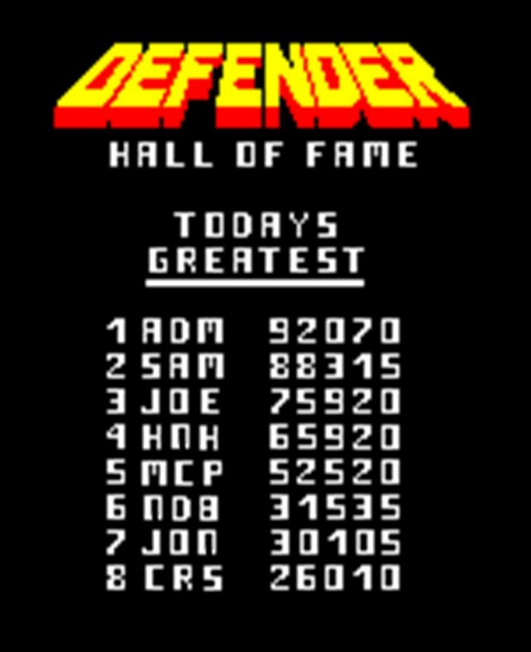Also, to make it more fun and engaging to the player, I could’ve added a score board at the end of the game, where players can put their name in next to their score as this may bring out a more competitive nature in the players meaning that they could compete for the best time with their friends, potentially making the game more fun to play. Also, the game could be improved by adding a score based on crystals collected or used and health at the end of the level, as this could’ve given the player more motivation to open off-route chests as currently there isn’t much point in opening lots of chests as you are able just run past all the enemies anyways, not necessarily needing to interact with them.

I could also add a resize feature to the game, I think this would make the game more accessible to people as currently, the screen that the game is played on is quite small and may be hard for people with impaired vision to play or could be considered visibly unappealing if the window doesn’t take up the whole screen.

I got a few of my friends to play my game and the main points of feedback from them that I got were that they liked the level design and they thought that the character animations were smooth. They said that this mage the game more interesting to play and added to the general aesthetic.

One issue that my friends had was that when the player opens a chest on an island the crystals sometimes spawn in a place above the bottom of the map where the player can’t reach without dying, this seemed quite discouraging and unfair for the person playing the game as they had gone out of their way to open a chest but couldn’t get what was inside.

Another thing they suggested was that I could implement screen scrolling vertically so that when player gets higher all the blocks also move up so that player is always in the middle of the screen. This would look better as when the level goes higher up sometimes the player ends up going behind the health bar and player statistics which makes it quite hard for the user to see what is going on, which could make it more difficult to fight enemies and less enjoyable to play.

The last improvement I received, was that I could include a feature where enemies turn red when taking damage, so player is able to see when they have damaged an enemy as it is more engaging, and the player knows that their actions are doing damage, up until the enemy dies. My friends said that it was a confusing for then trying to kill an enemy and not knowing whether they did damage or not. I could also do this for the player and make them turn red when they are taking damage so that it is easier to tell if you are taking damage without looking at the health bar as most of the time the player’s focus is on where the player is on the screen.

Another feature I could add is additional levels as there are only five levels and I could even develop a level editor similar to the one in games such as *Geometry Dash* to make players able to create levels allowing a higher rate of engagement with the players and the overall game. This would give the user a lot more freedom and creativity than they had previously.

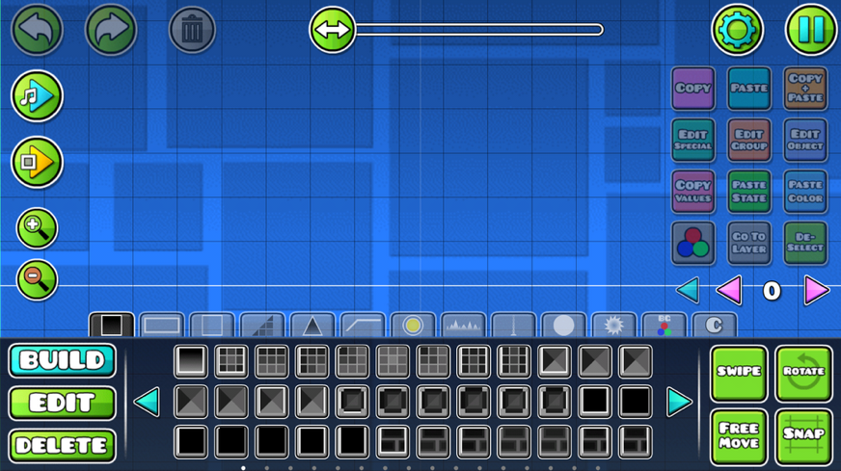

I thought there was a few things I could improve about the enemy AI. Firstly, I could make it so that enemies know not to walk off the edge of the map while patrolling their area, as this gives allows a chance of all of the enemies already being dead when the player gets to them which wouldn’t be as fun or engaging for a player. Another feature I could improve about the enemy AI is to make it so that the enemy limit for going up blocks is 2 blocks which is the same as the player as currently on some of the levels with drastic height differences the enemies go all the way up an 11-block tall wall which looks a bit strange and doesn’t fit into the game very well. The last thing I would improve is that when enemies are in caves if they go up to the edge of the cave, they end up going to the bit of the map on top of the cave due to the code controlling the enemy’s movement that makes enemies go up when they hit a wall.

One last thing I would change if I spent more time on this game is having more integrated sprites as for the current game all my sprites and map tiles came from different places and different artists and some are more detailed than others and don’t fit together as well as I would like them to, so I would either make my own sprites or find sprites that are slightly more similar to each other than they currently are.

* In conclusion, I really like the mechanics, controls and idea of this project and I think that is a fun game to play but there are a few improvements that could be made or that I should consider if I make another game similar to this one. I also think that I met my target market as my friends that I asked to test the game enjoyed it and I also enjoy playing the game and the target audience were people my age.

1. https://github.com/pygame/pygame
2. <https://arks.itch.io/dino-characters>, <https://www.spriters-resource.com/>, https://opengameart.org/content/2d-tiles-0
3. https://ezgif.com/sprite-cutter
4. https://www.photoroom.com/background-remover/
5. https://pinetools.com/pixelate-effect-image
6. Attached as appendix
7. <https://mixkit.co/free-sound-effects/> I found some of the sound effects here
8. I sometimes refer to crystals as gems or balls in my program
9. Here my time to complete level 1 is an outlier as it is longer than level 2 and 3, however this is because I was using some of that time to complete other tests